Deploying Book Application On AWS

1.**Creating DB from RDS.**

Open RDS Dashboard. We can view page like below. Click on create database.

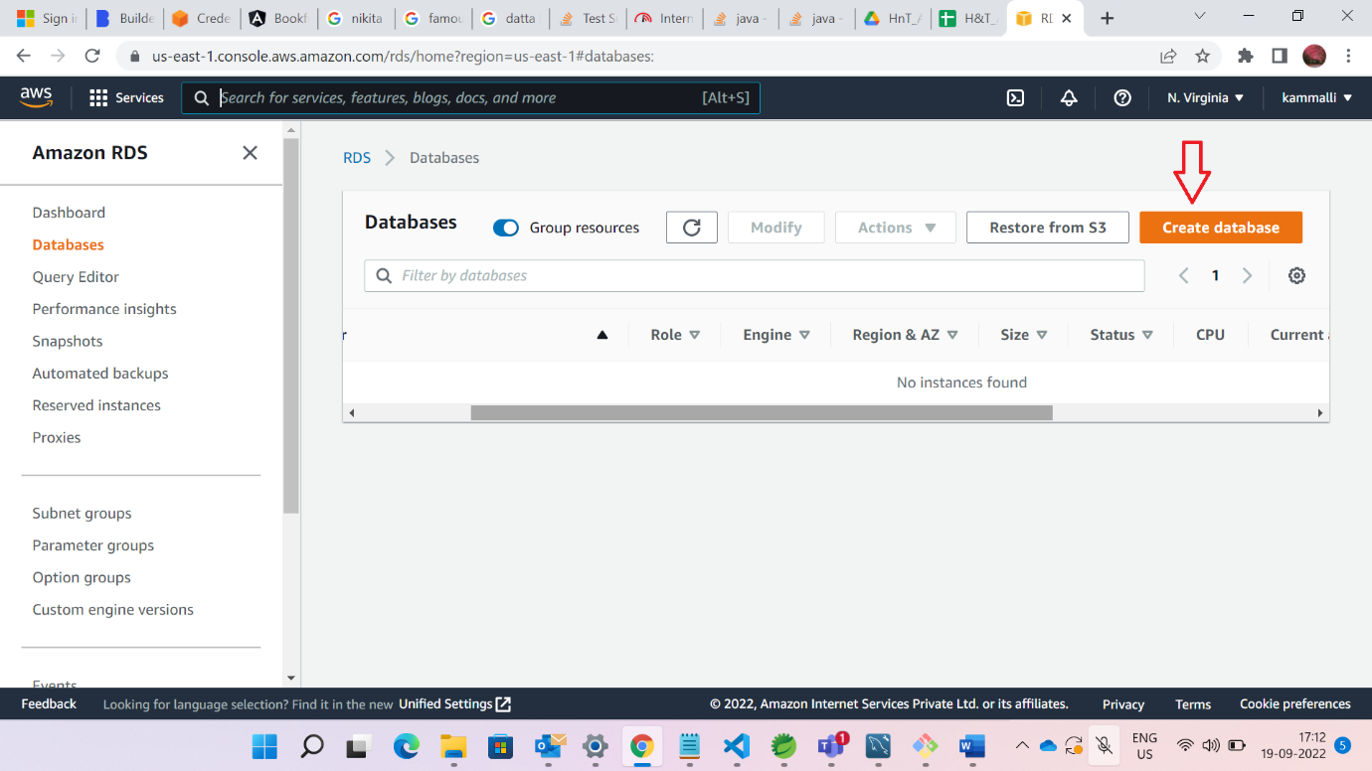

Standard option we need to choose

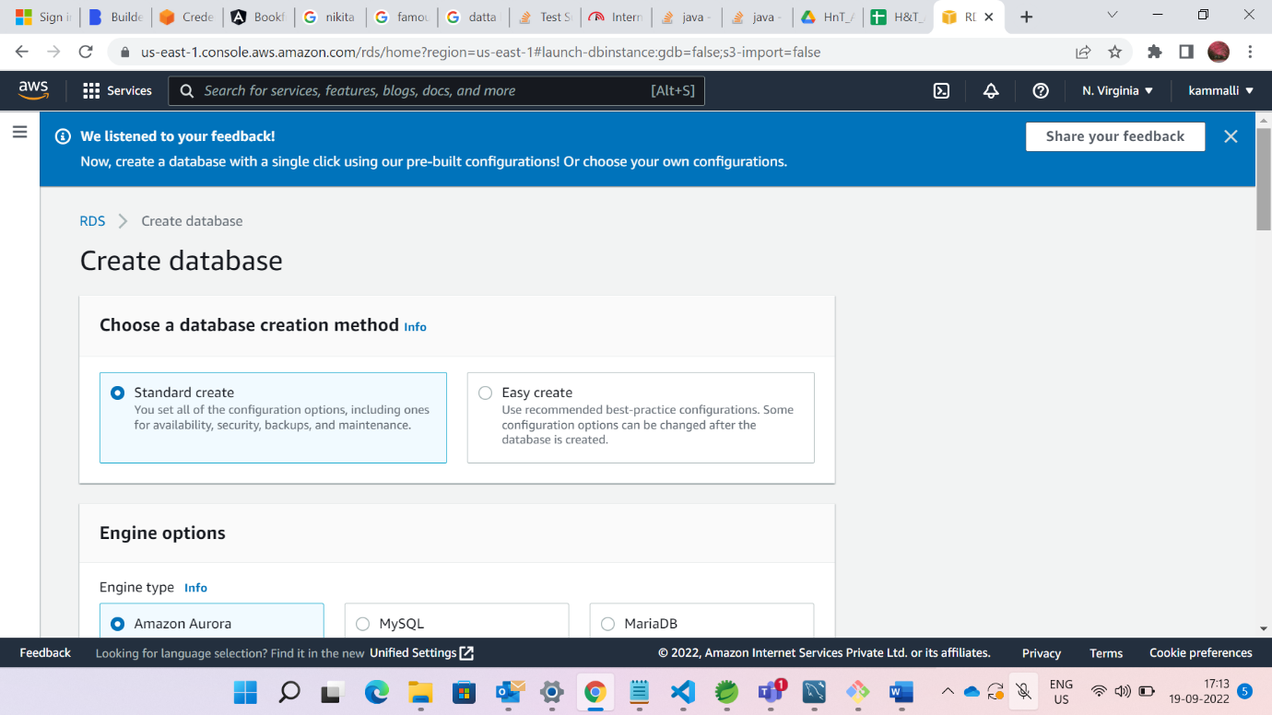

Select Mysql Aurora

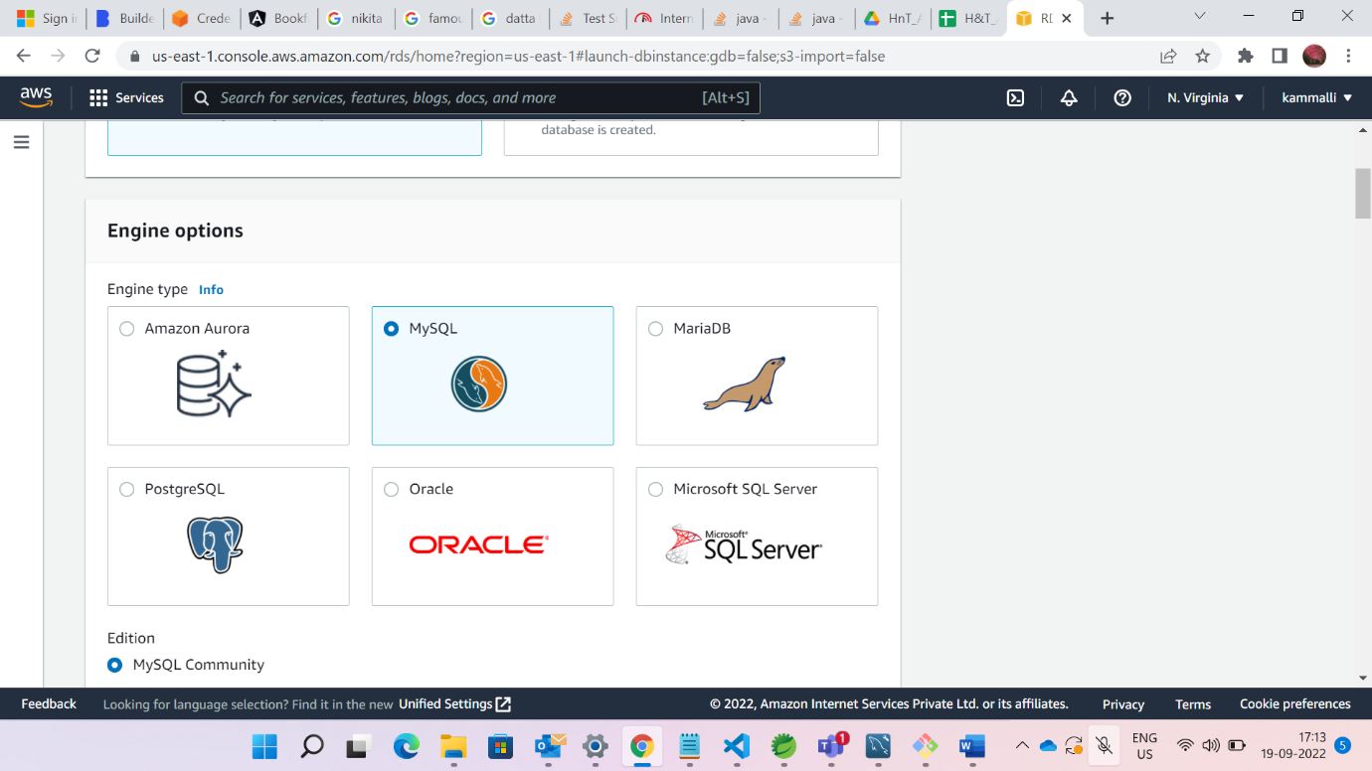

Choose free tier

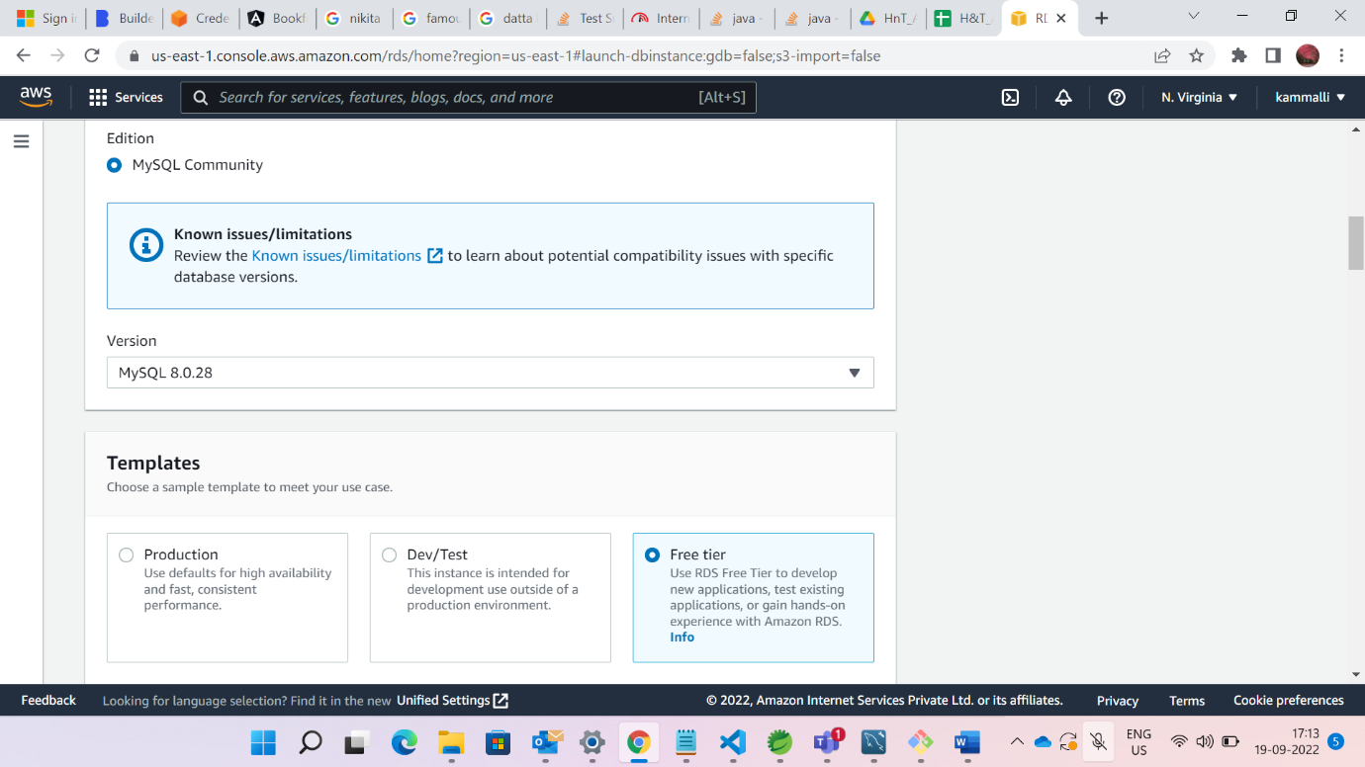

Give Instance name, username and password

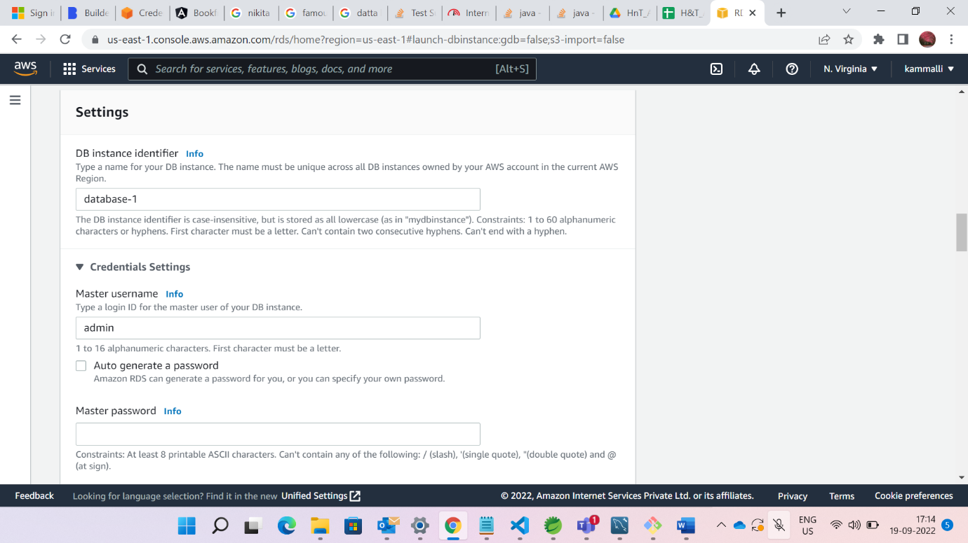

Keep below settings as it is

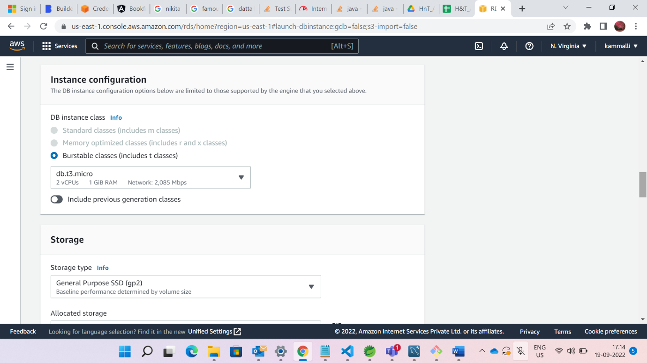

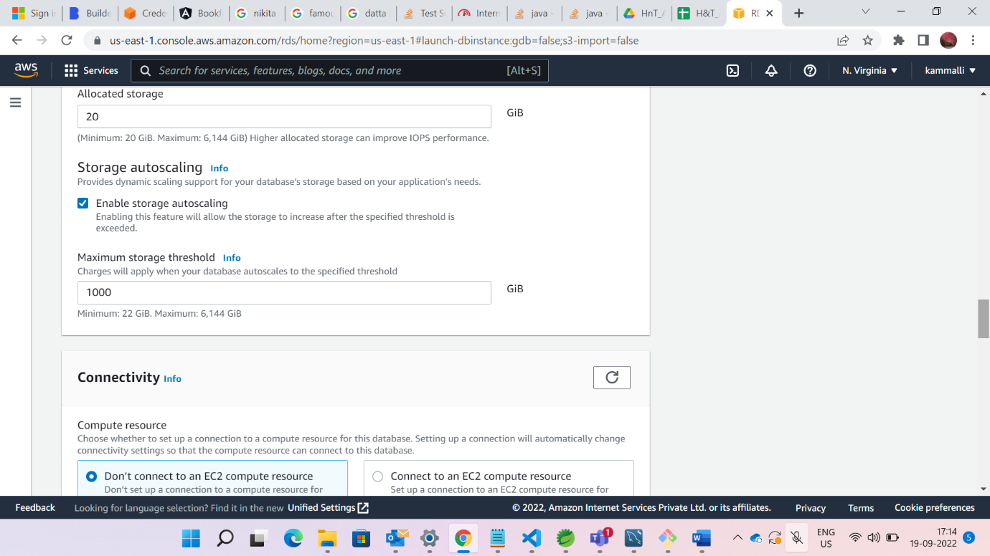

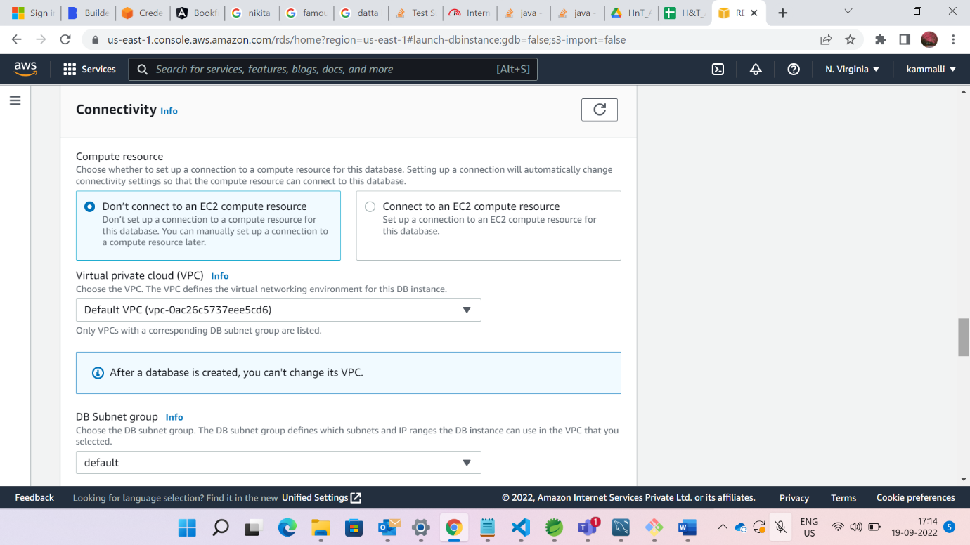

Click on Create database

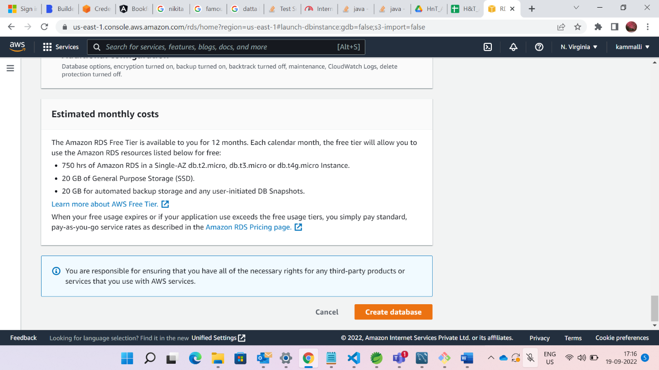

After creating Instance screen looks like below

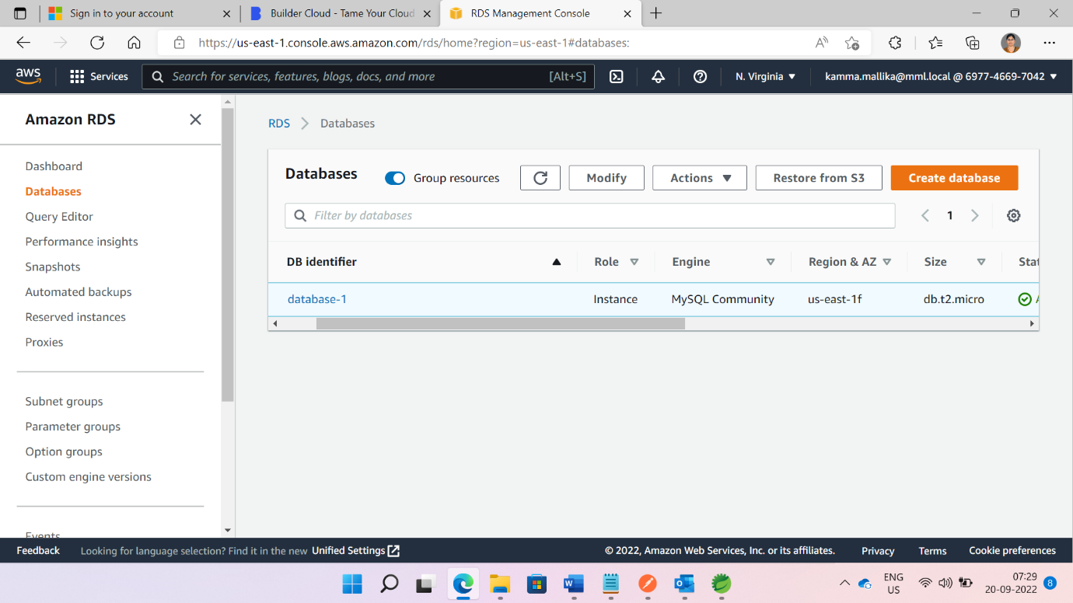

After clicking on databases1 from above pic .We can access database by using endpoint and port from below pics

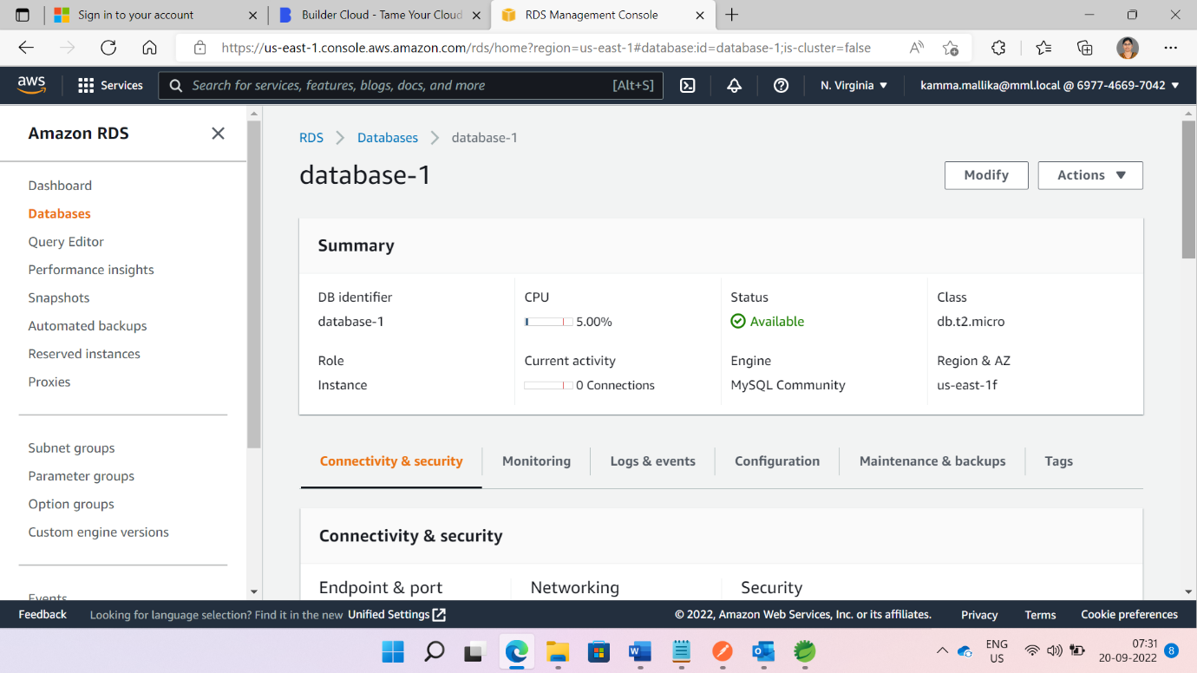

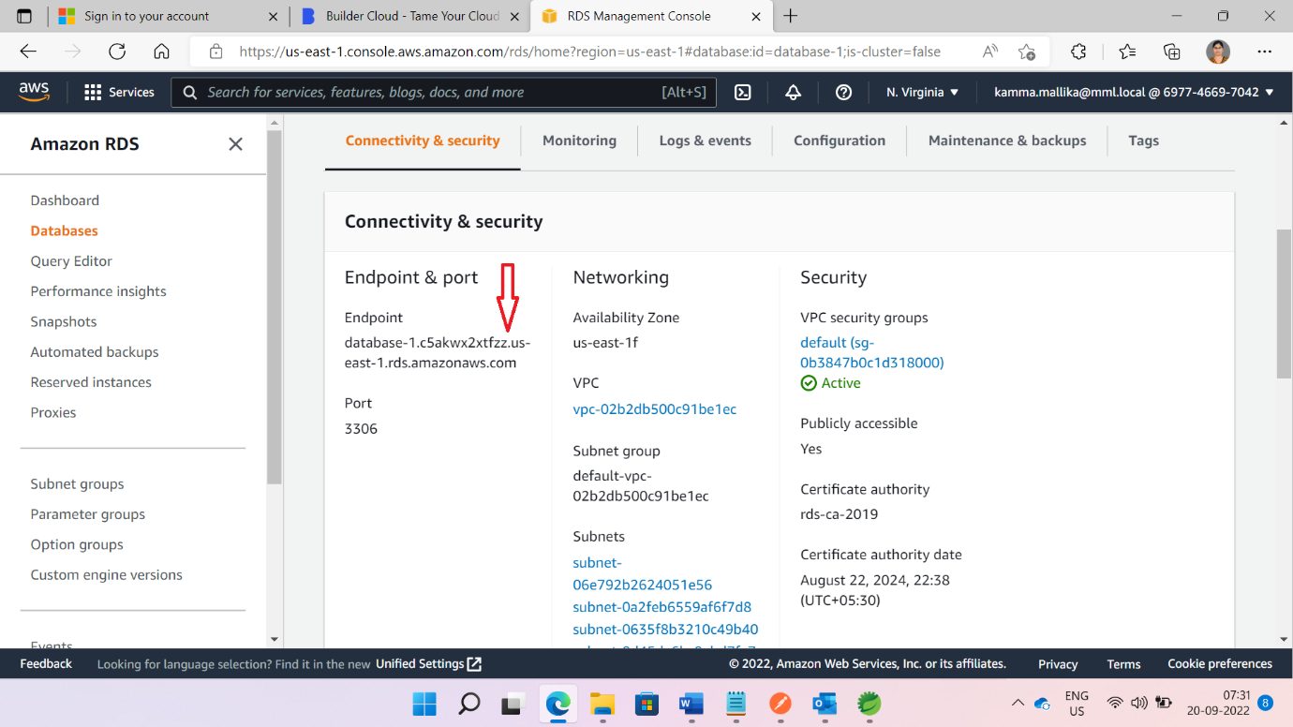

Click on Settings from Security group rules

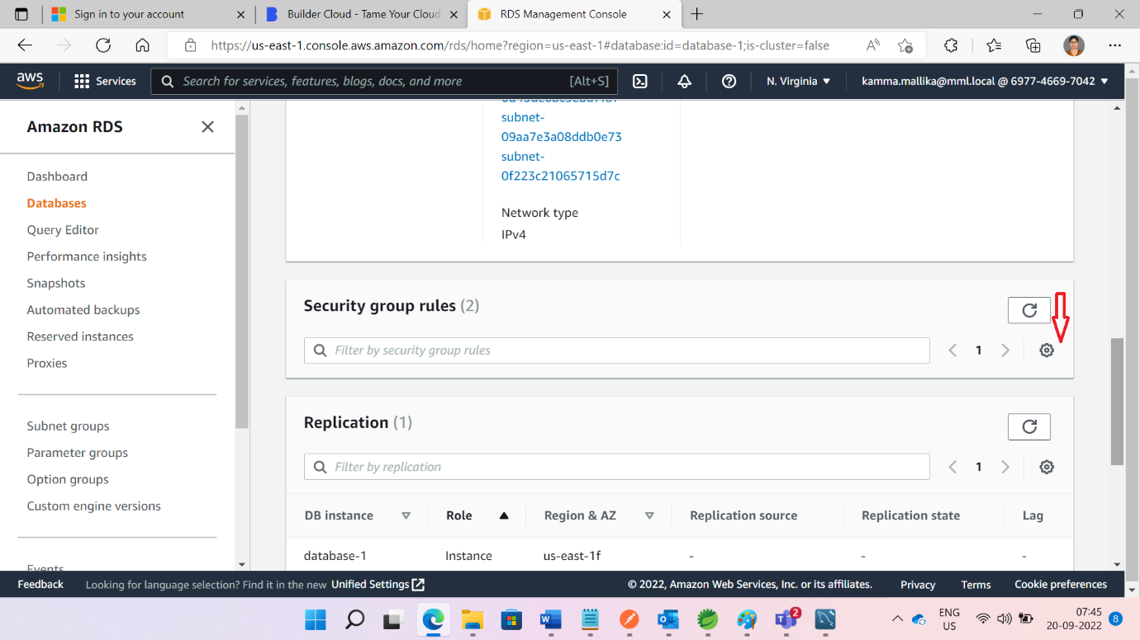

On the three buttons from below pic and click on continue.

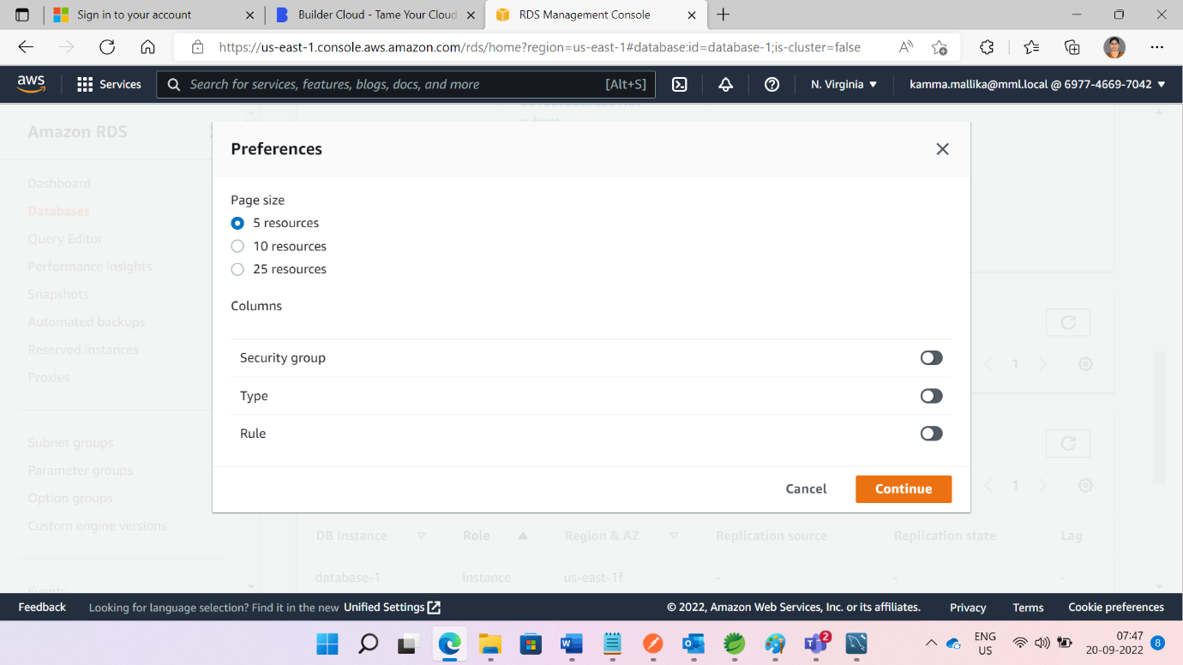

Page looks like below

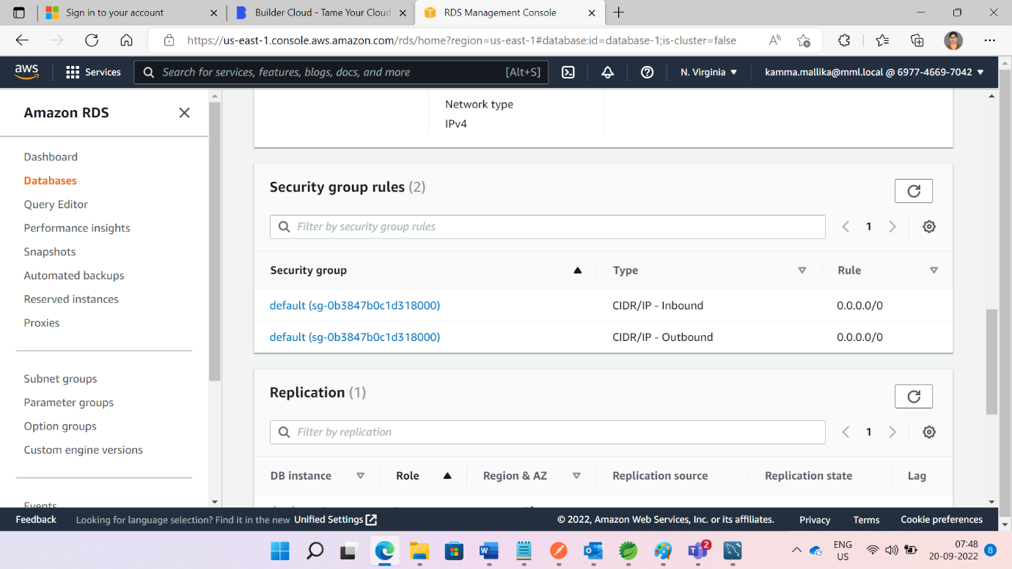

Inbound and Outbound rules should like below

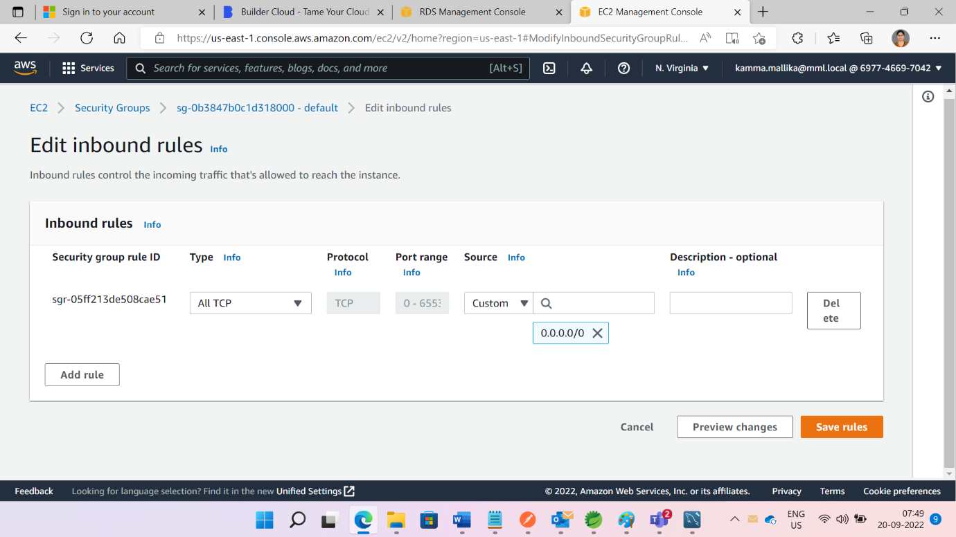

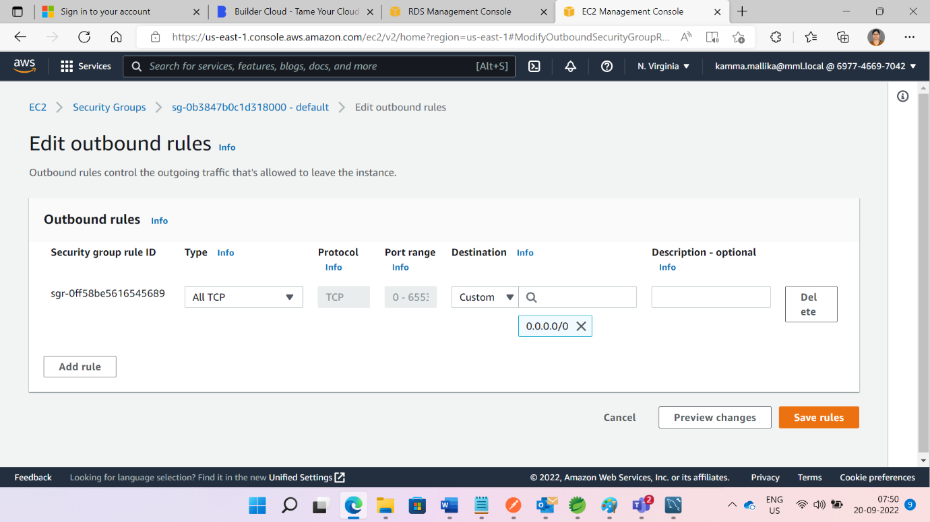

Copy Endpoint and Port .Open mysql Workbench and Click + button from below pic

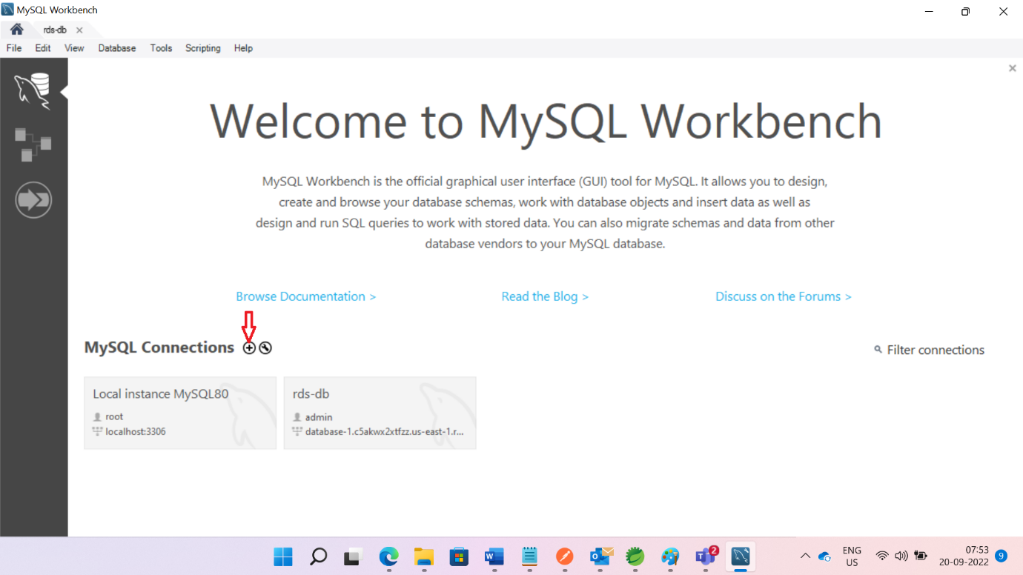

Give Connection name,Username,password ,Endpoint ,port and db name

Test Connection

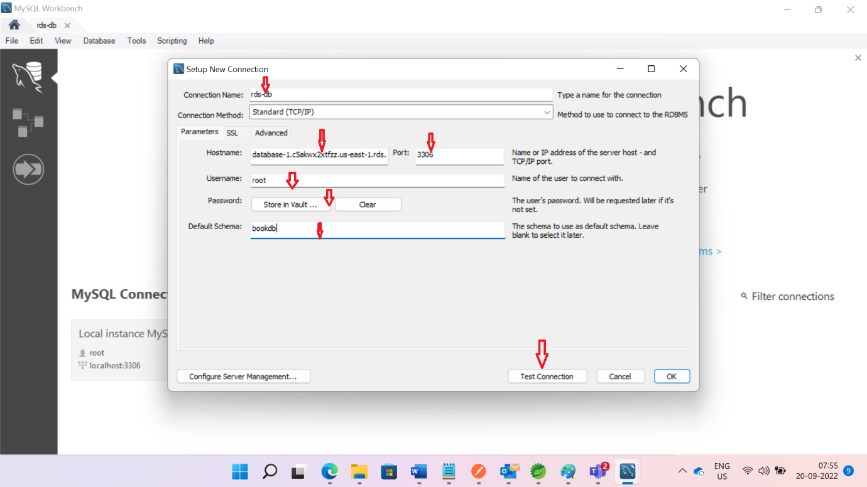

We can view page like below with bookdb

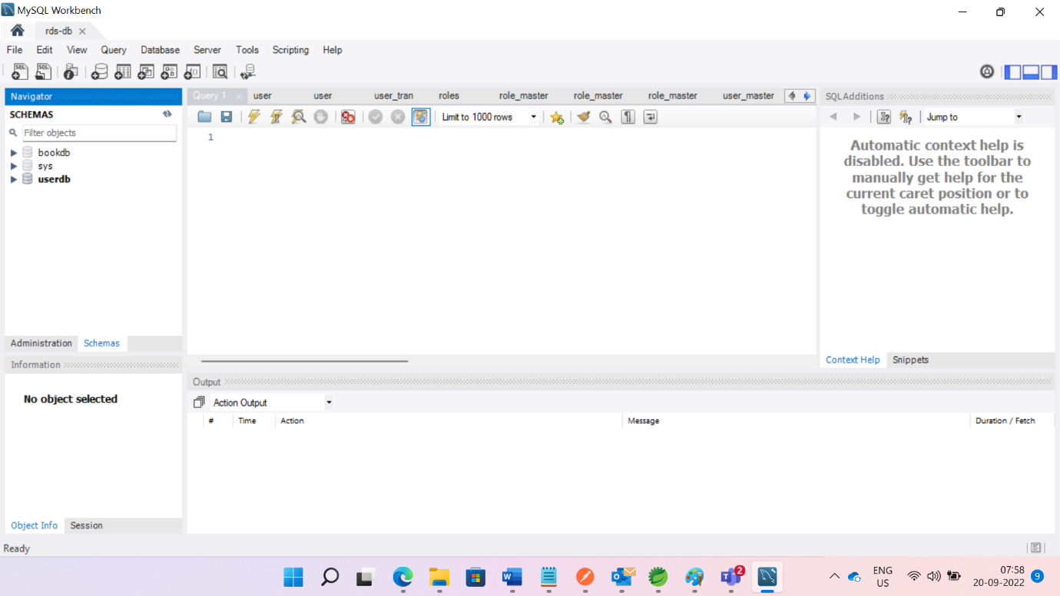

Give these Endpoint and port ,username,password details in STS book application of application.properties.

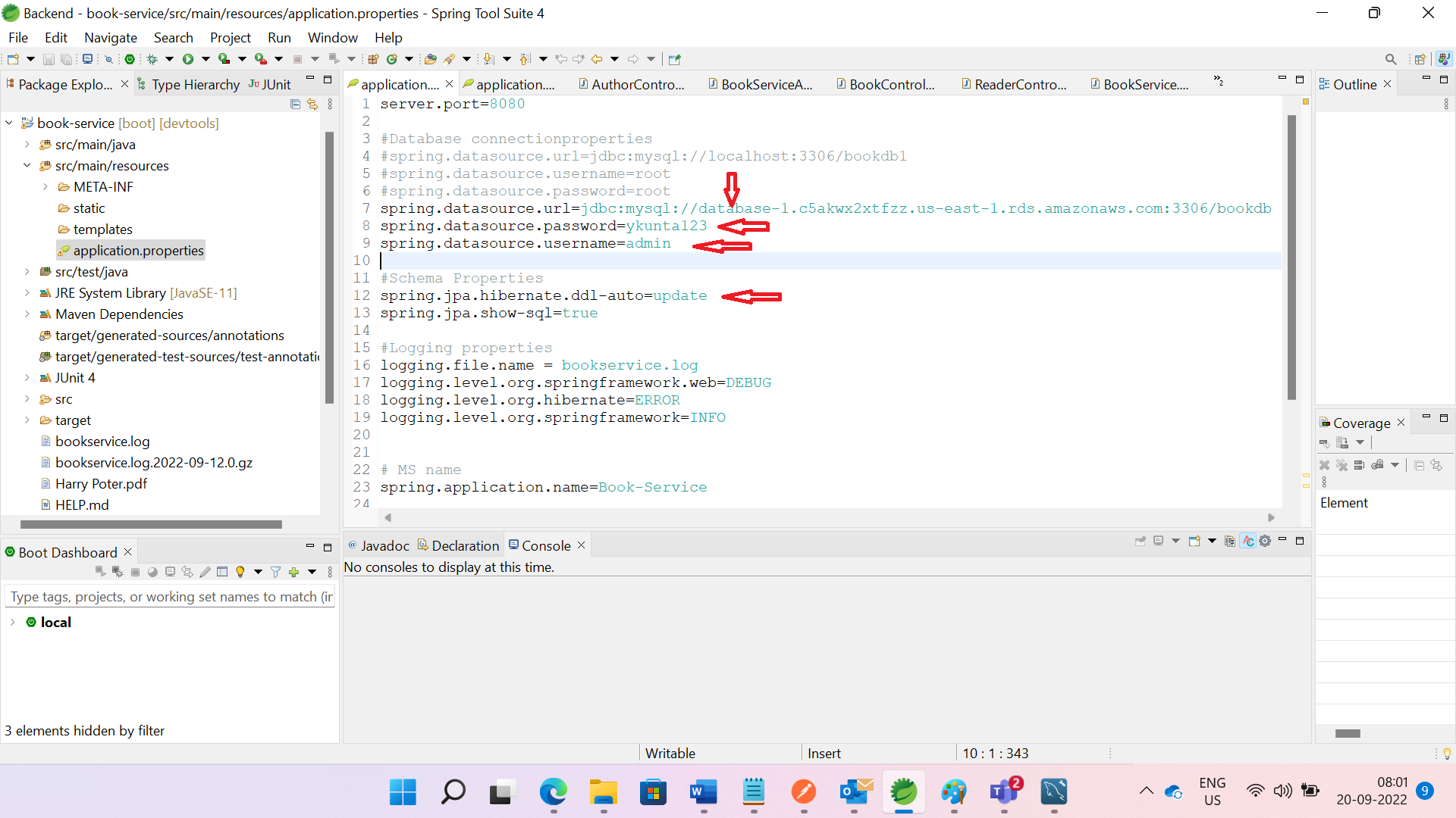

Run the application

Then tables will create in bookdb automatically like below pic

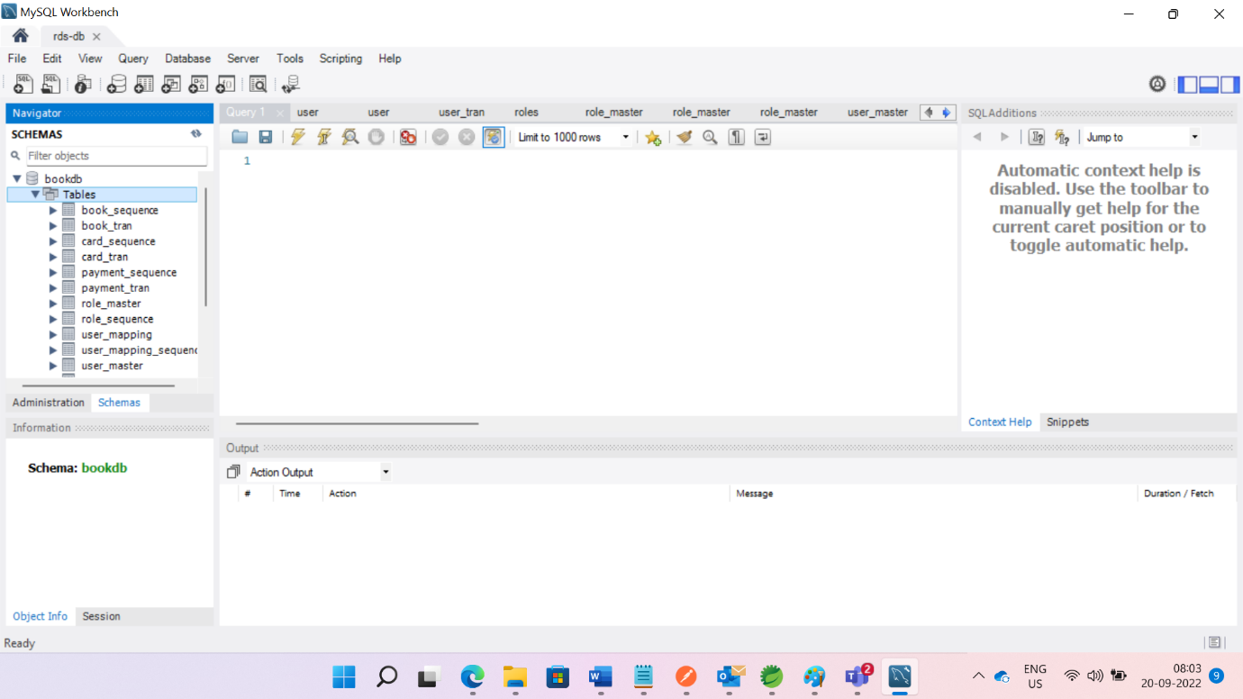

2.**Creating EC2 Instance**

-----------------------------------------------------------------

Open Ec2 Instance Dashboard. We can view page like below.

Click on Instances

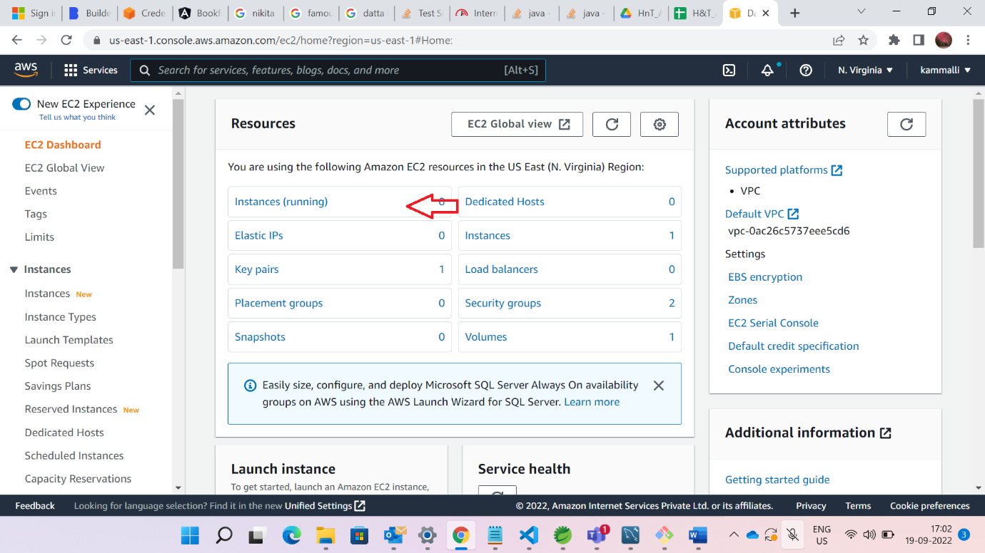

Launch Instance

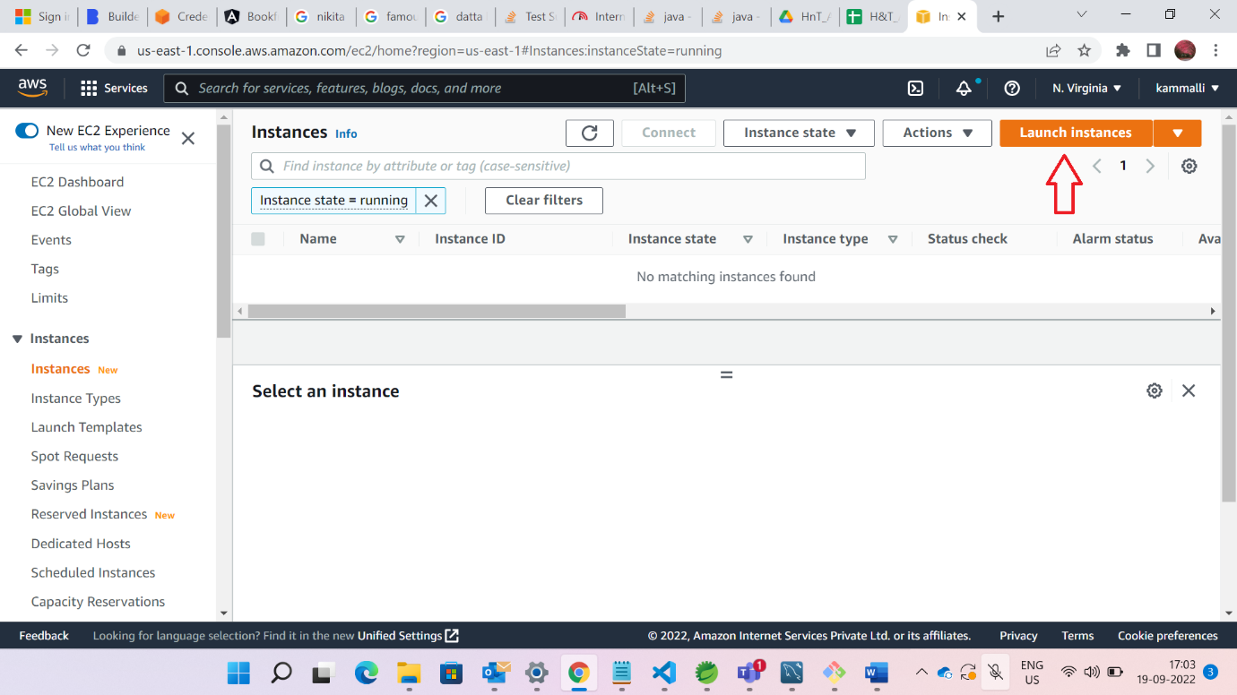

Give name of your ec2 Instance

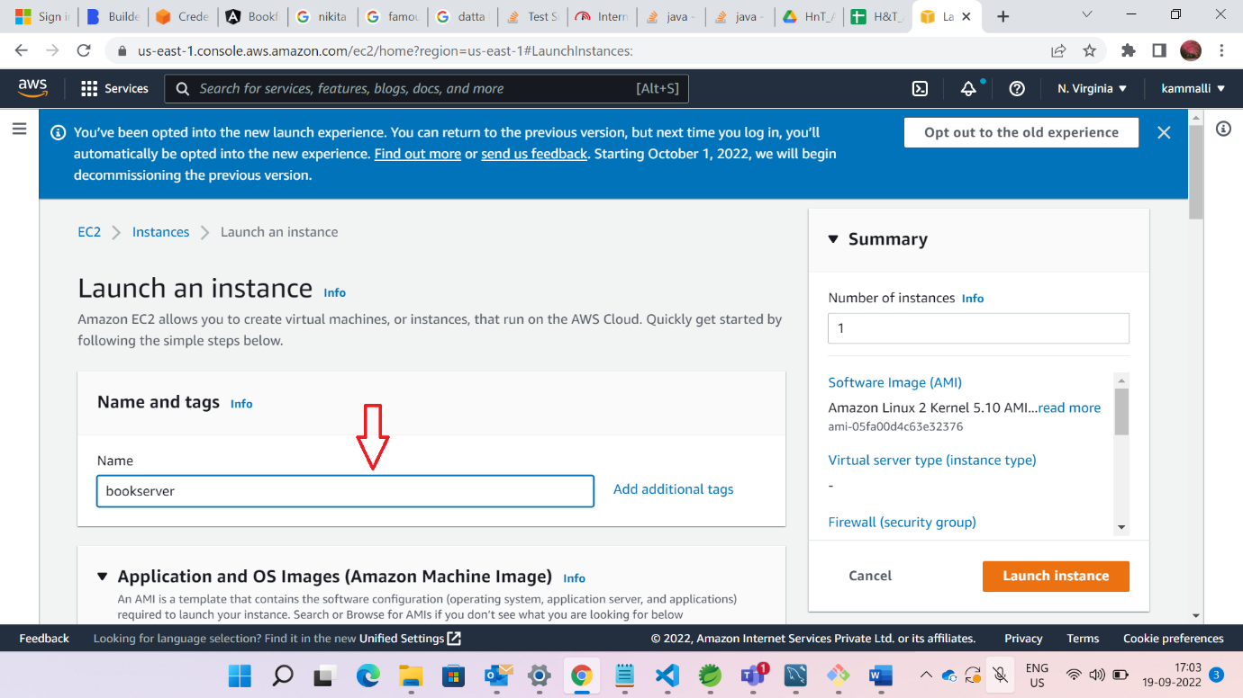

Check on Windows Server

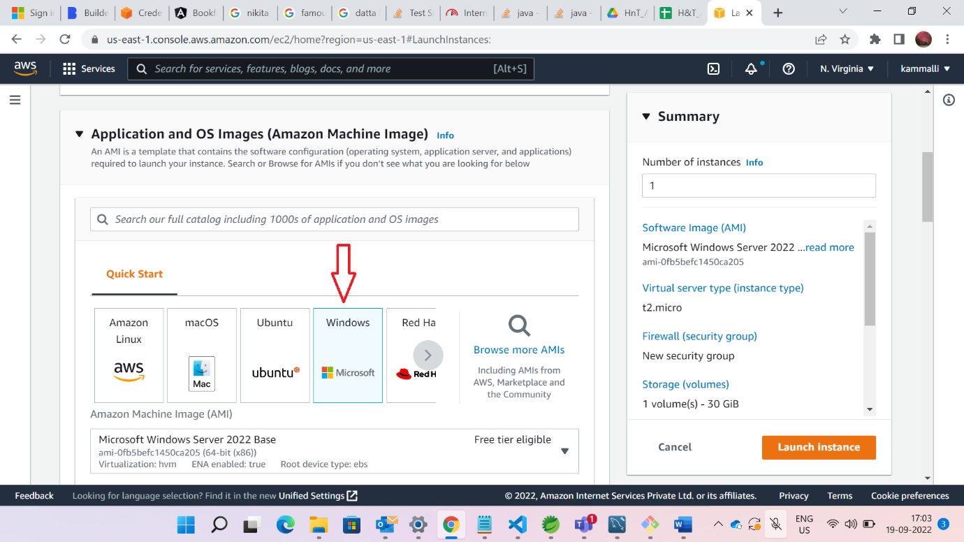

Click on create new key pair

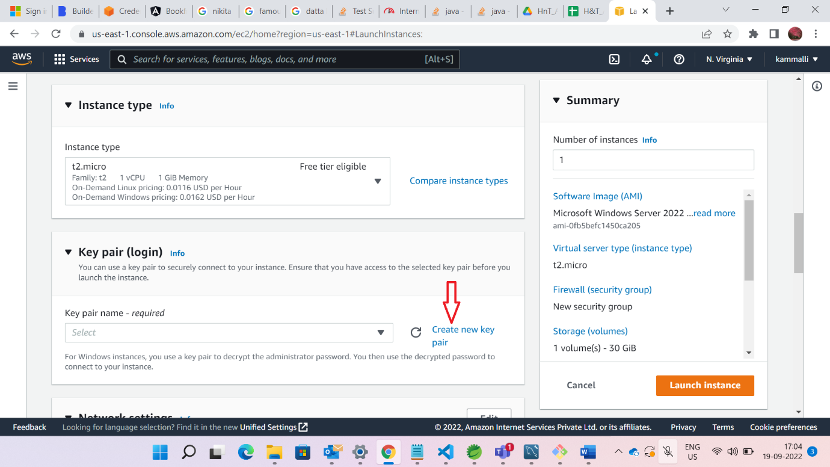

Give the name for new keypair, select .pem file and click on create new key pair button. Then .pem will downloaded. Keep that file in some folder. It will be used for logging purpose.

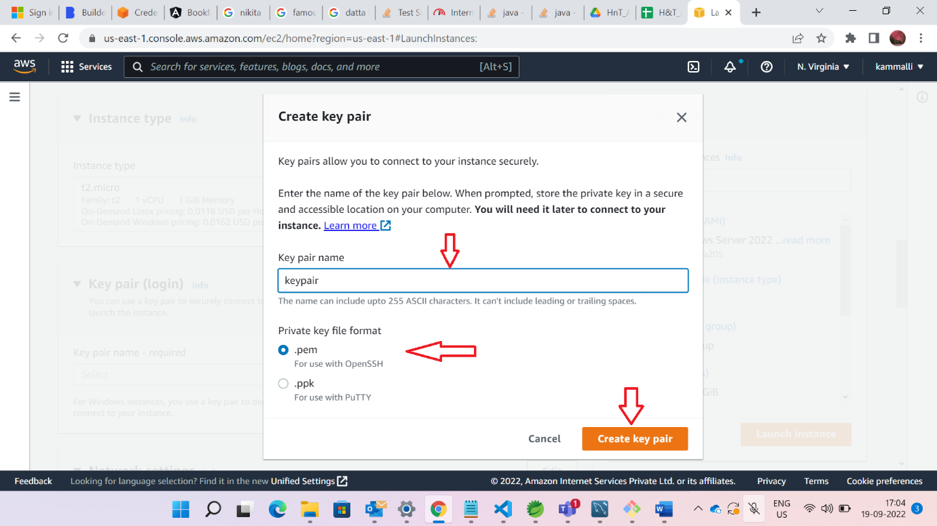

Click below check boxes as show on below figure

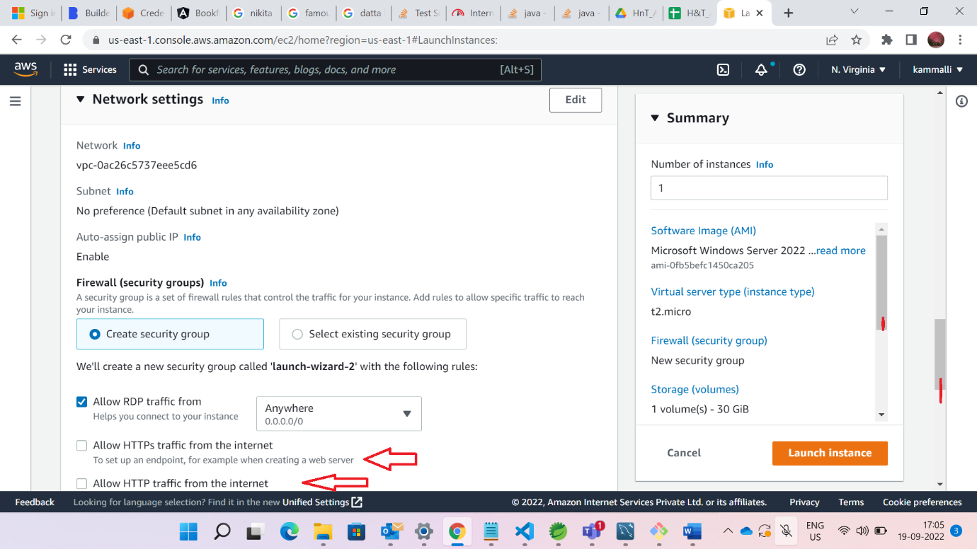

Click on Launch Instance button as shown in below figure

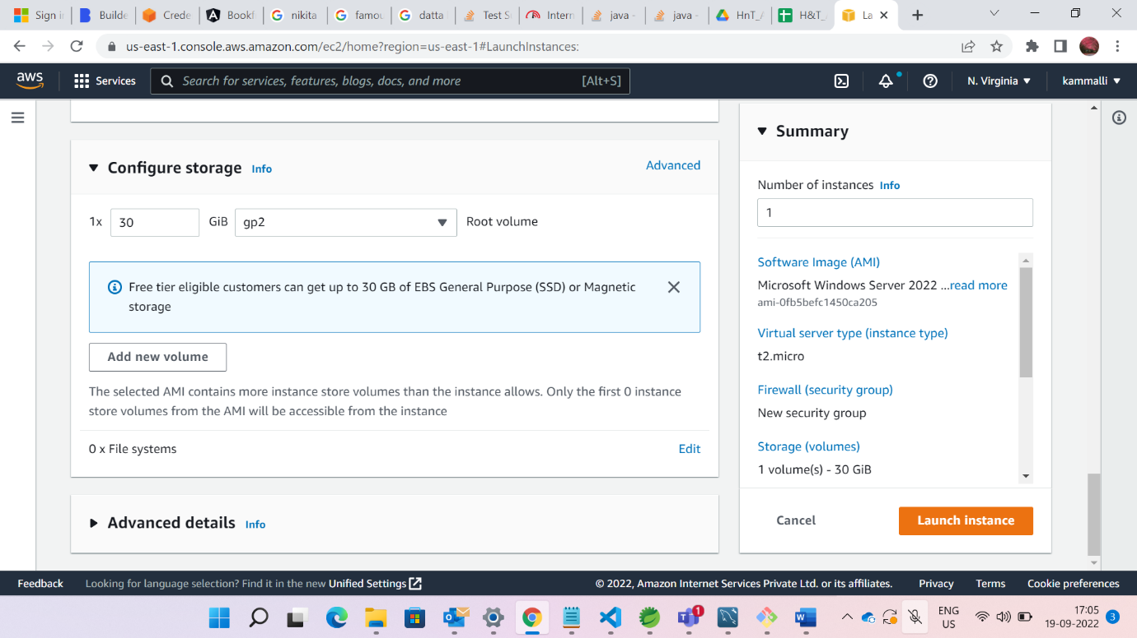

After launching instance . Instance is created.

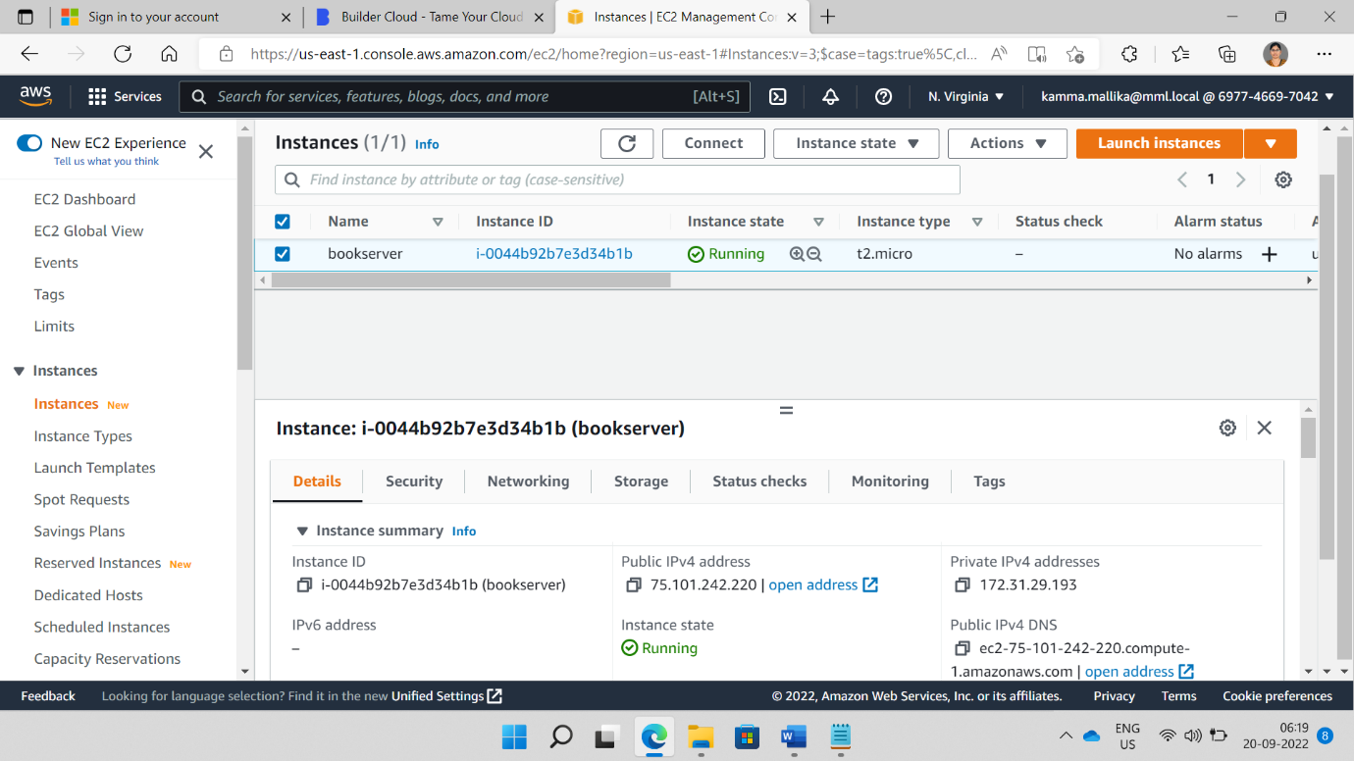

We need to add security groups

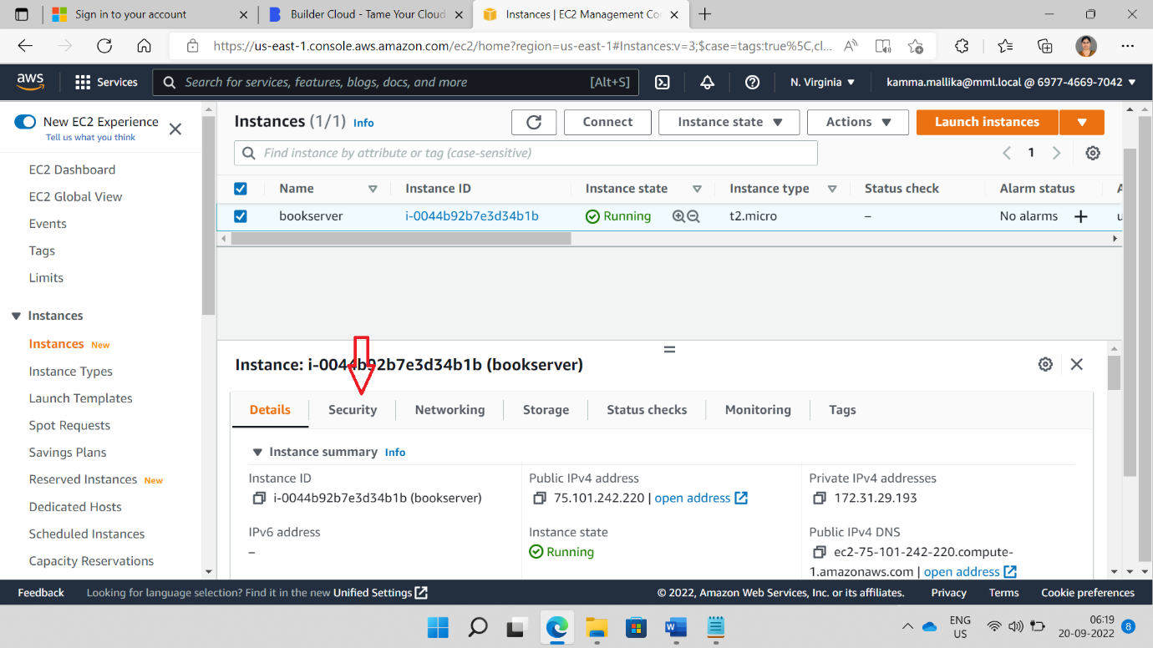

Click on Security group link

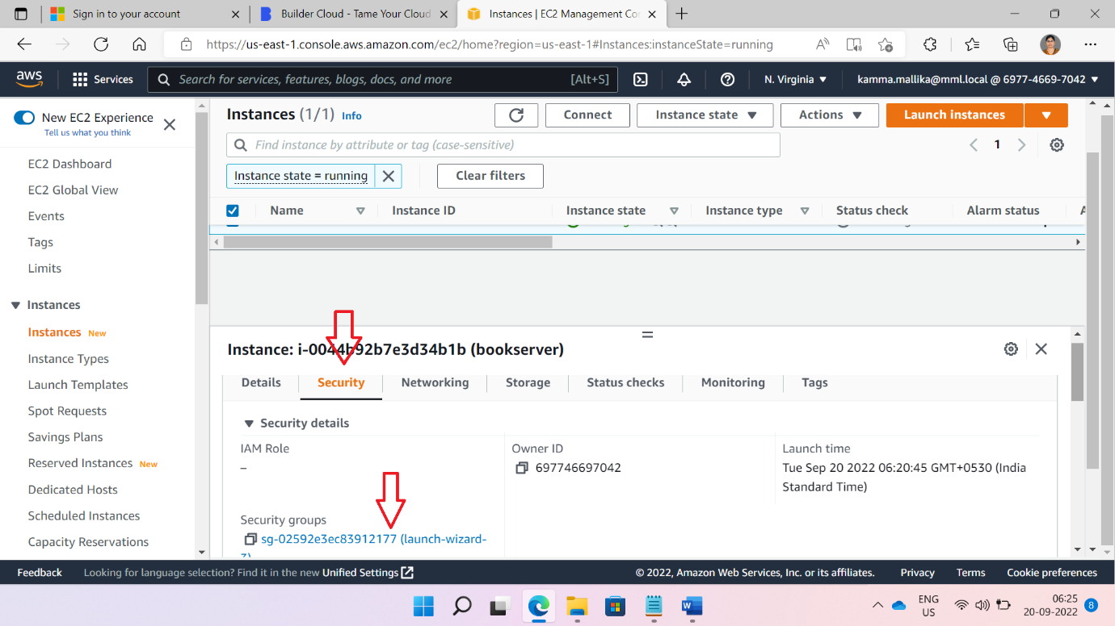

Click on EDIT inbound rules

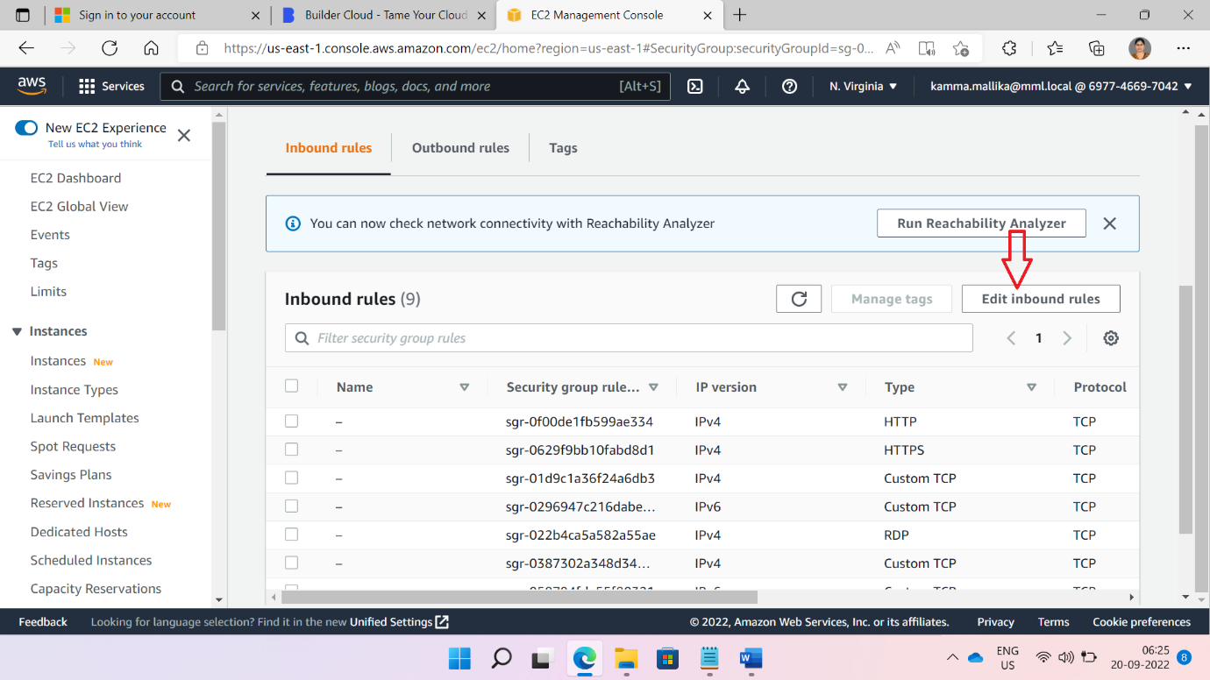

Add two rules of Ipv4 and Ipv6 with custom TCP and port number of on which application is running

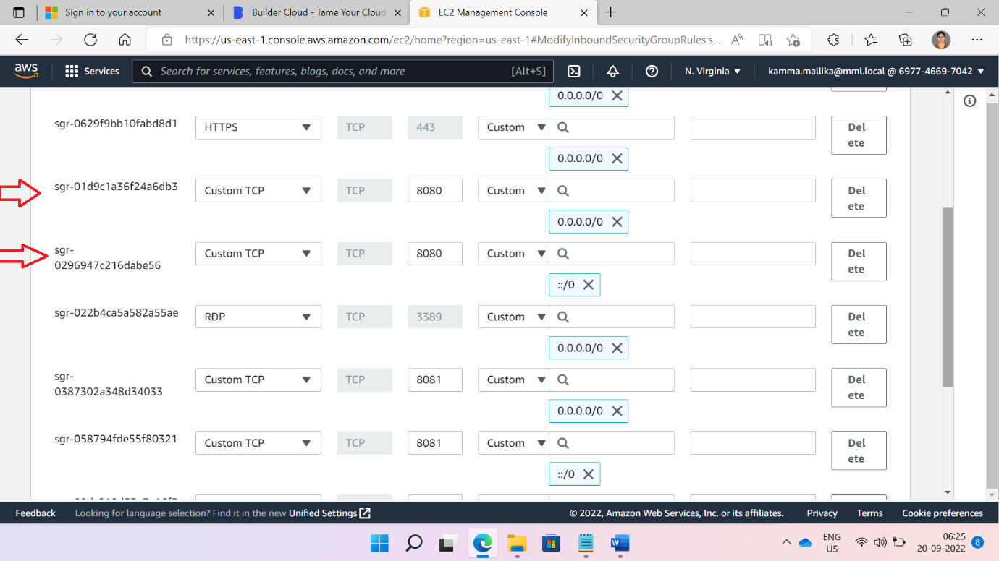

After that click on Save Rule Button

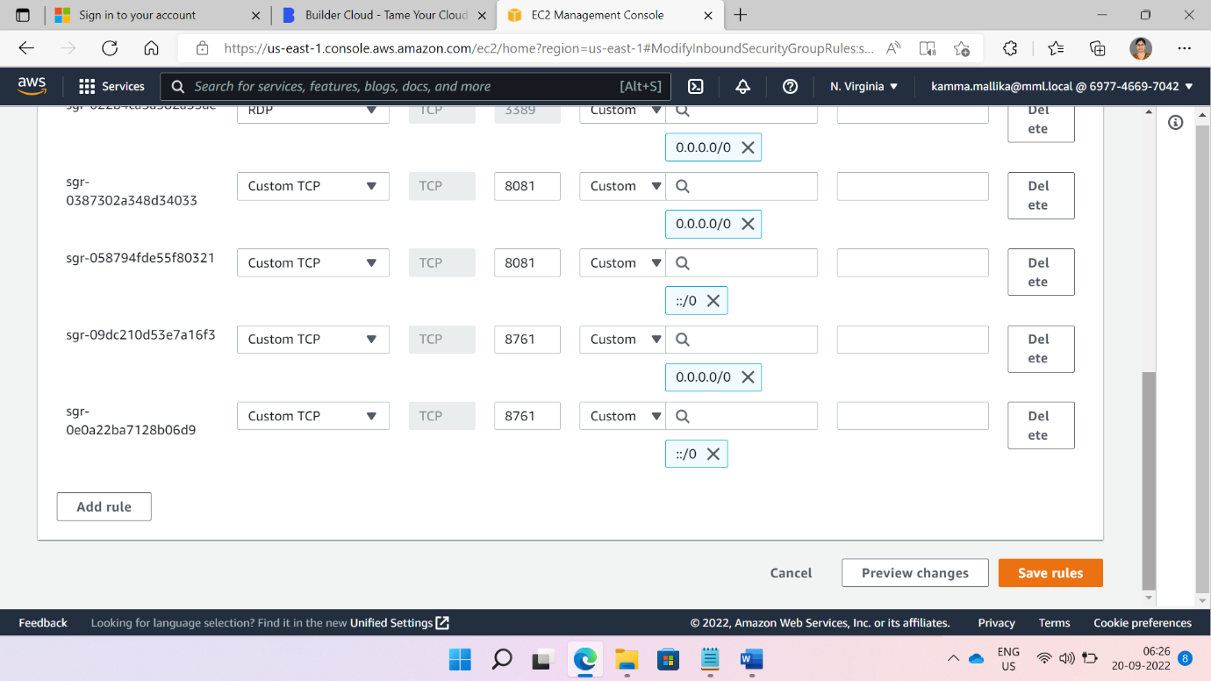

Connecting to ec2 instance. Click on connect button at the top as shown in below picture.

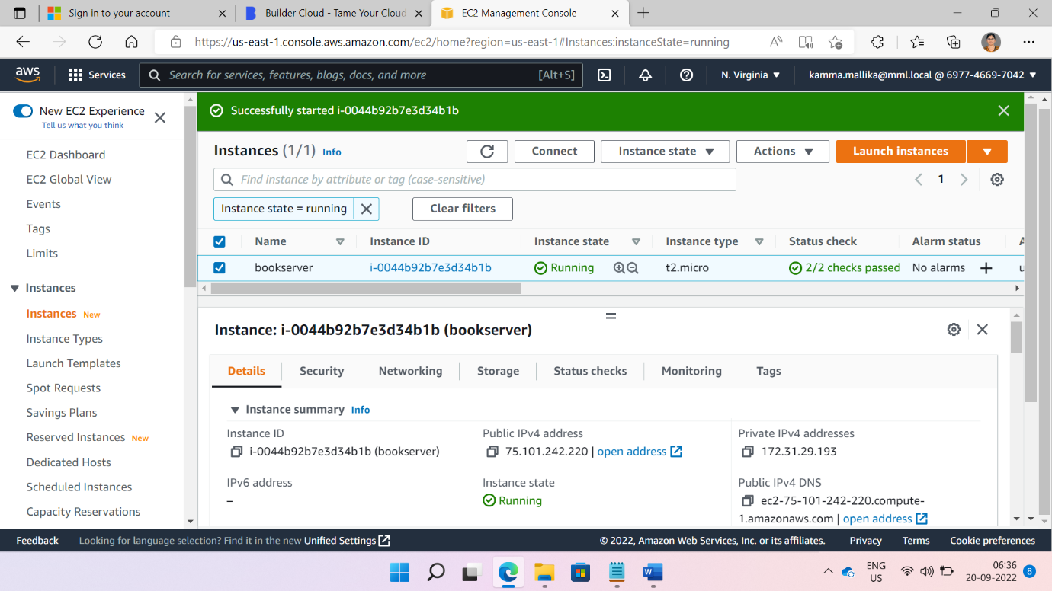

Click on RDP Client

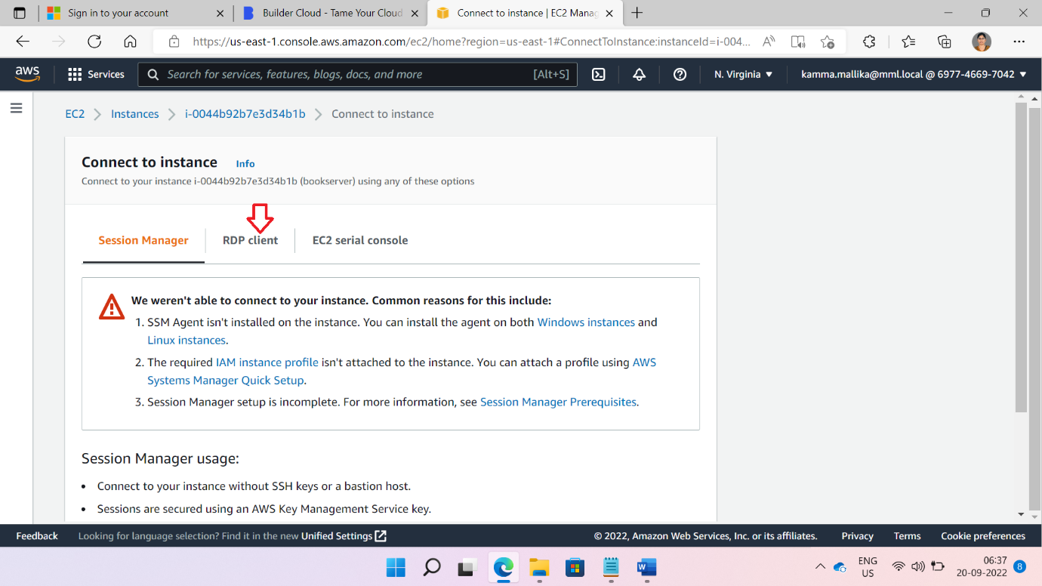

Download Remote desktop file.

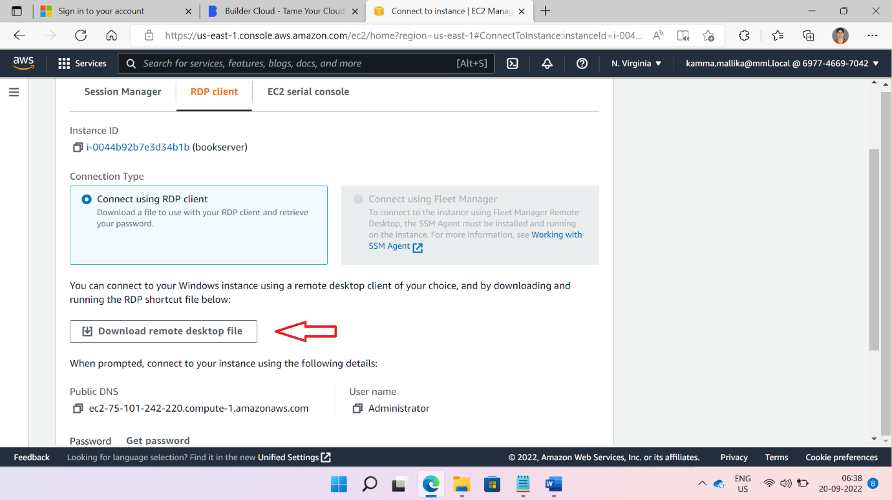

Click on Get Password

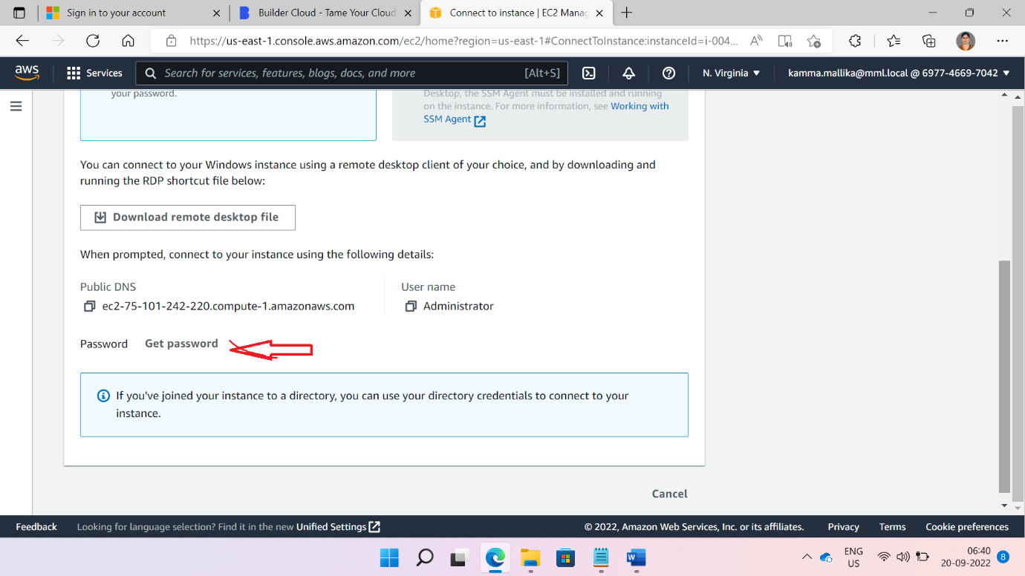

Browse .pem file and decrypt the password. We will get password of RDP .

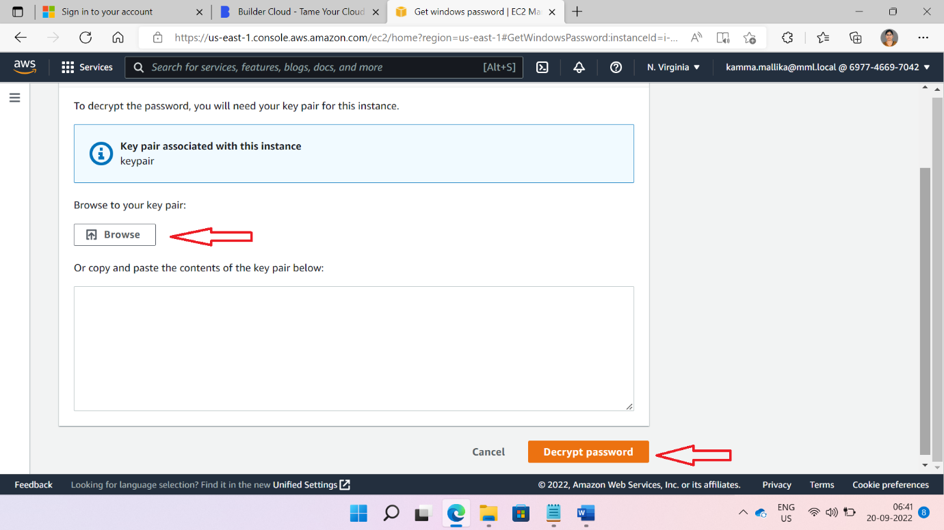

Save Password in secure place.

Click downloaded RDP file and click connect button as show in below figure

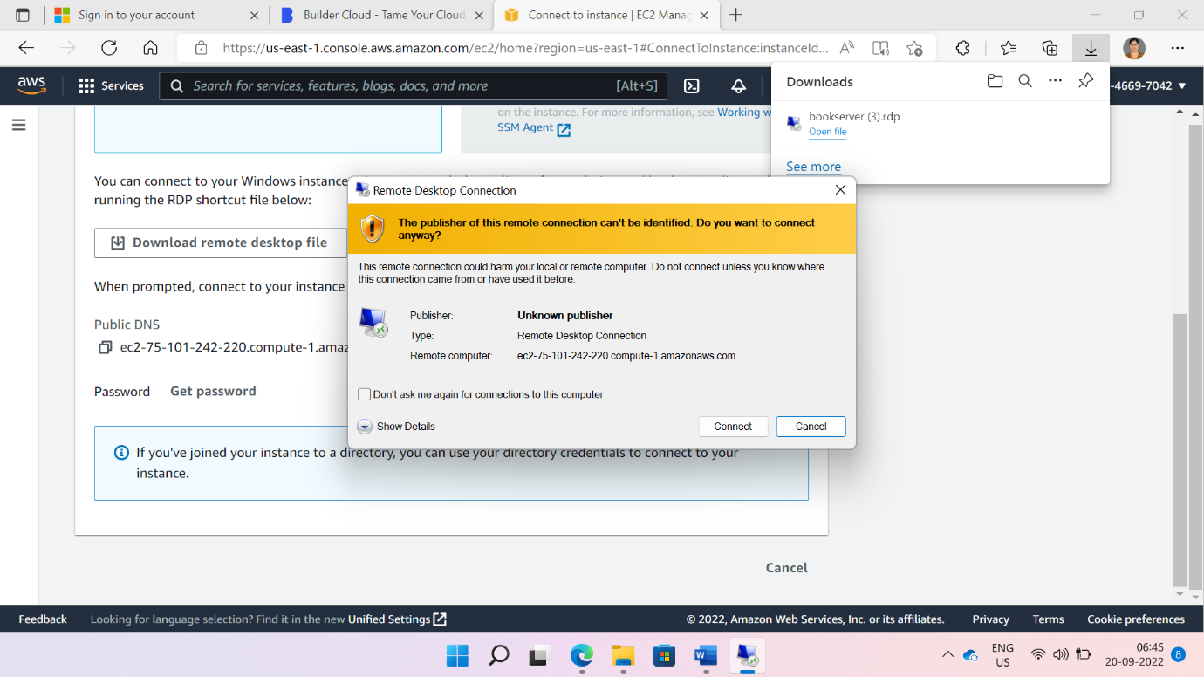

Give Decrypted password.

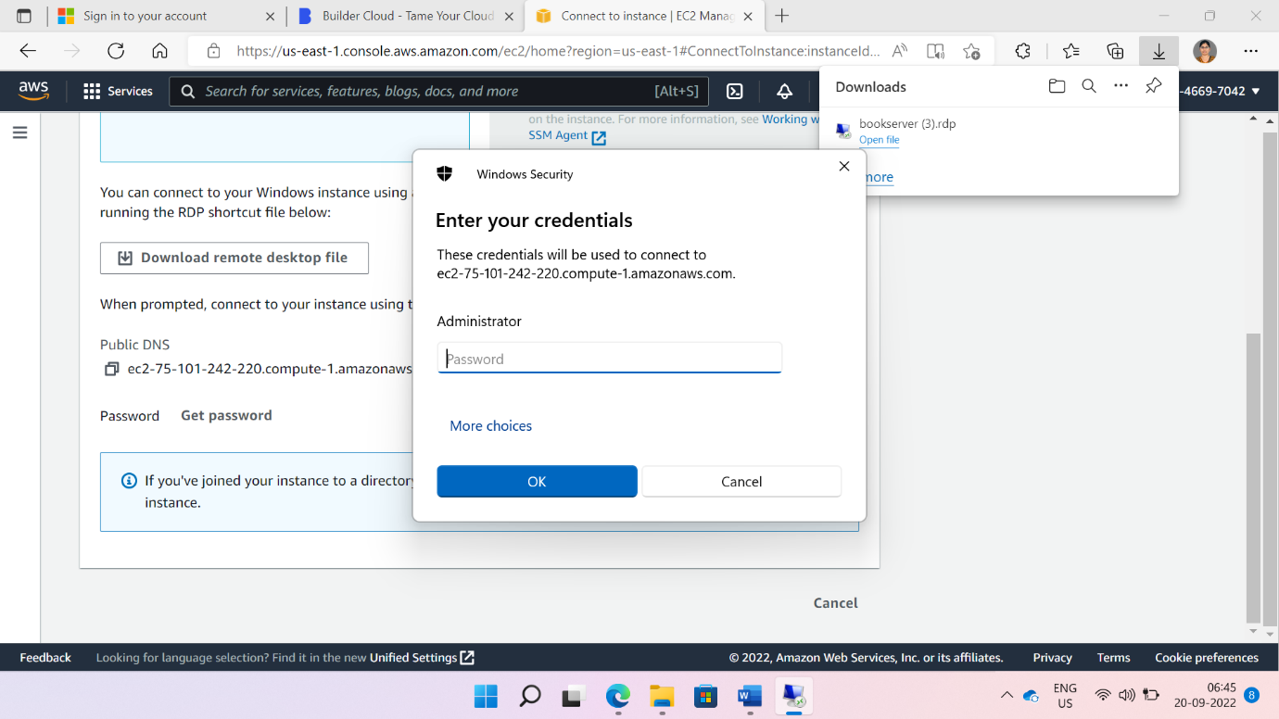

Click on Yes button

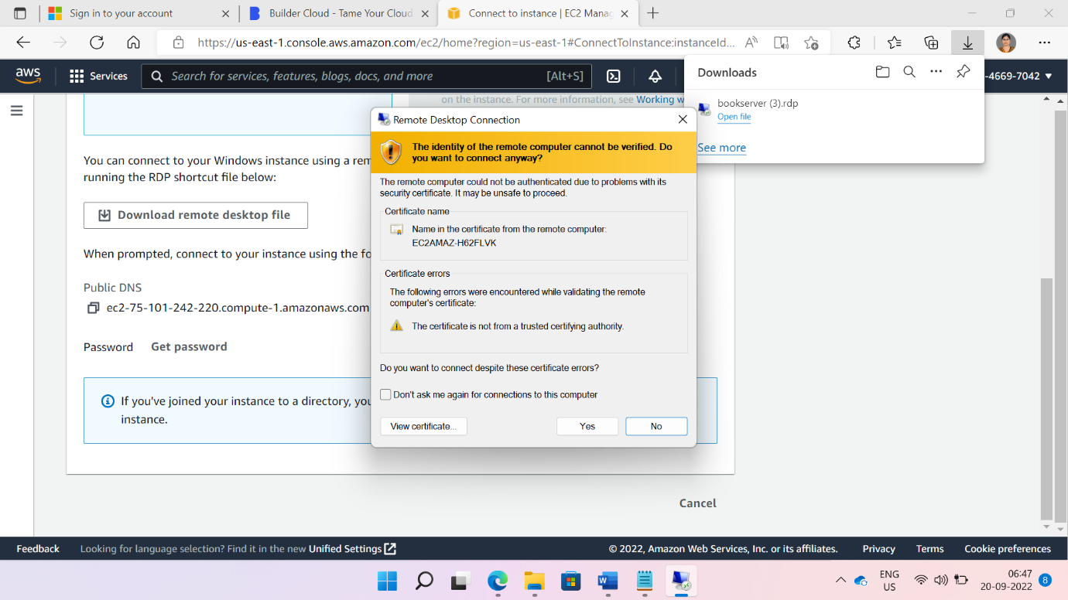

Note: Make sure in security tab the Windows FirewWall should be off in ec2 to instance.

Copy or download JDK file in any folder. Install downloaded JDK file

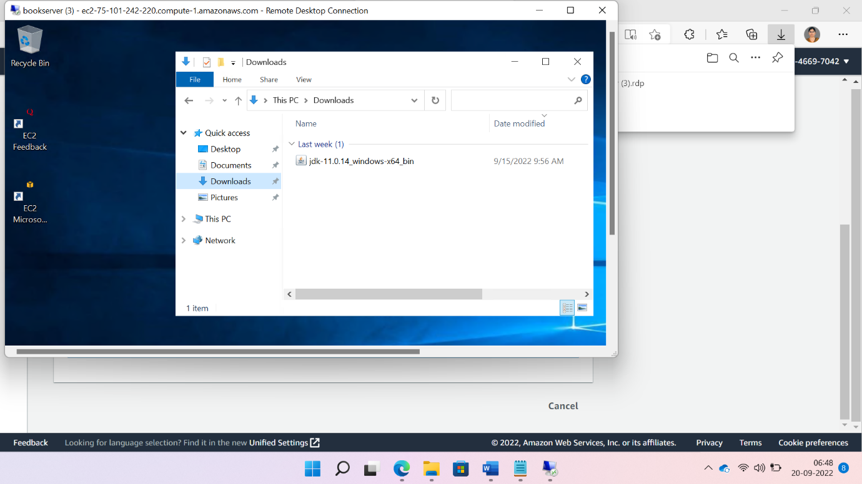

Make the Jar of your application from root folder of application

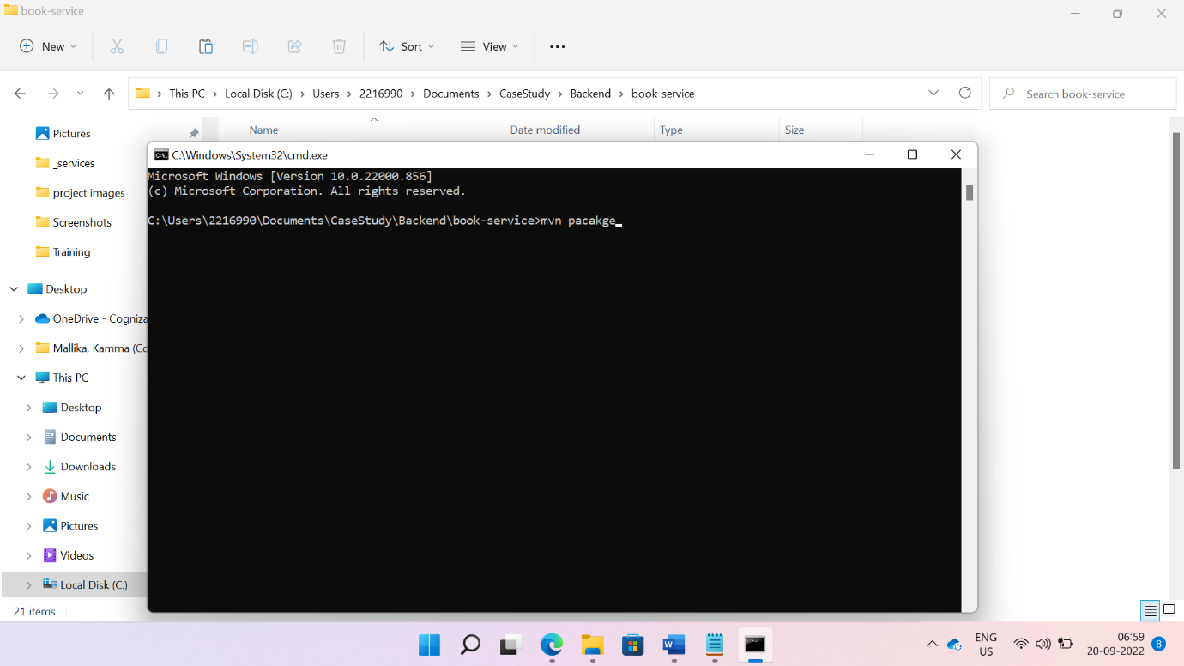

Check in target folder

Copy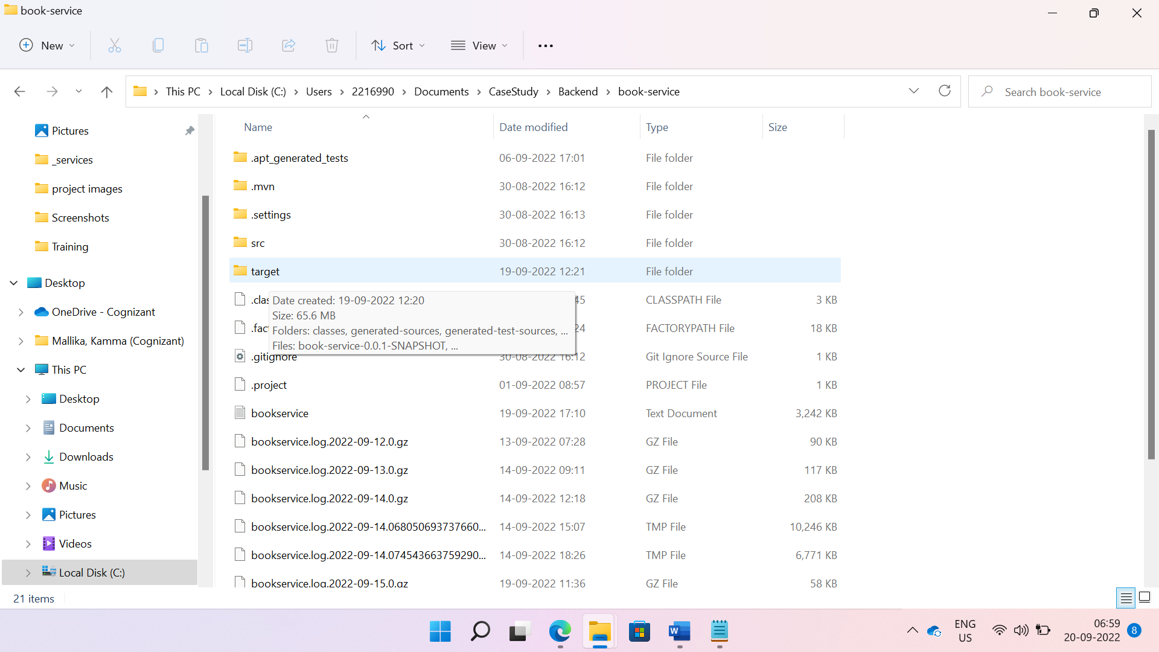

Copy jar from target folder and paste in ec2 instance.

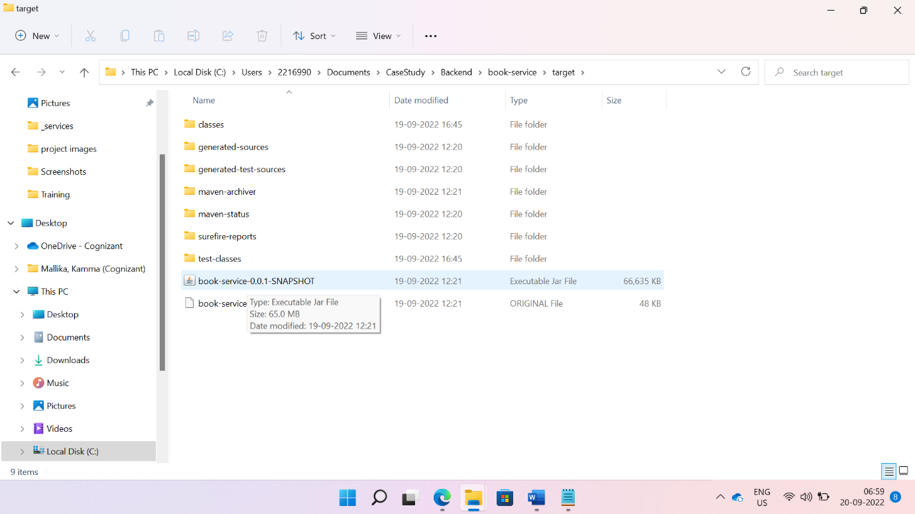

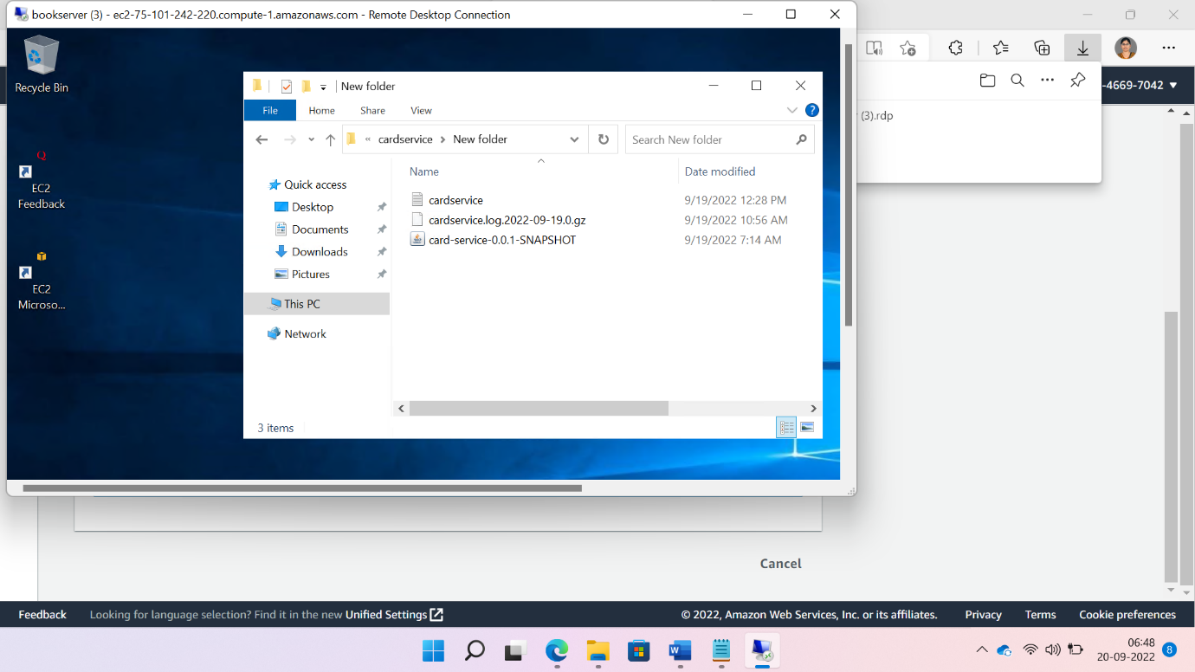

We need to run the jar file by using java -jar yourjarname.jar .

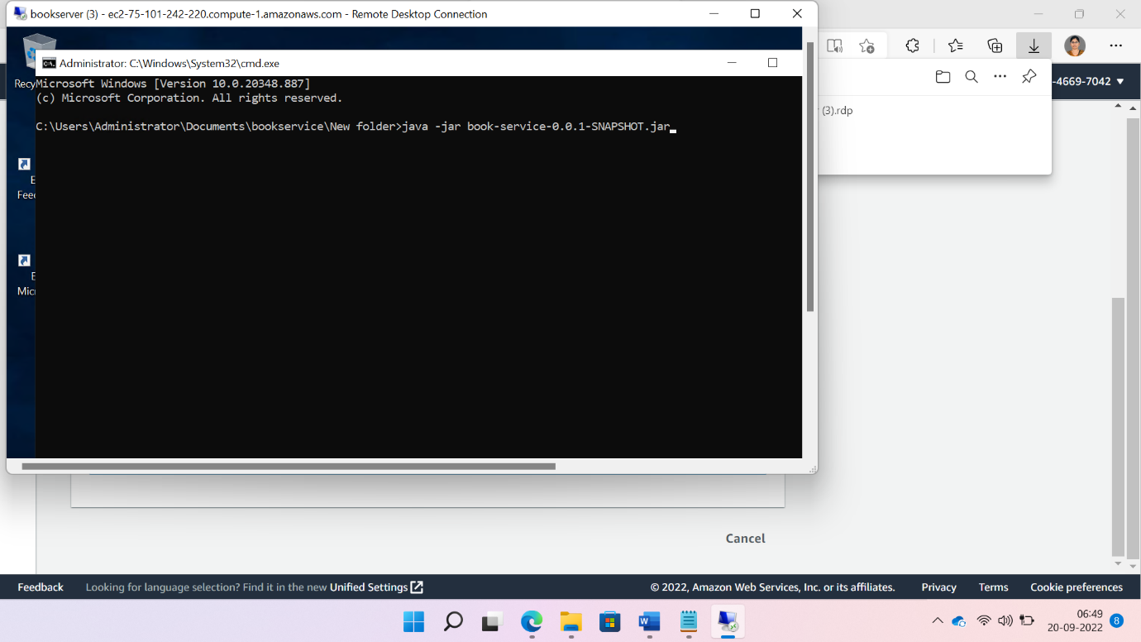

Copy ip4 address

TesTe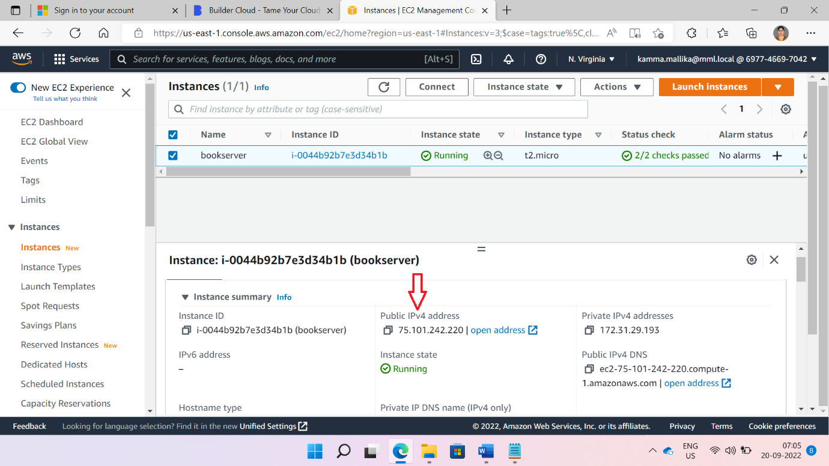

Test your rest api from post man.

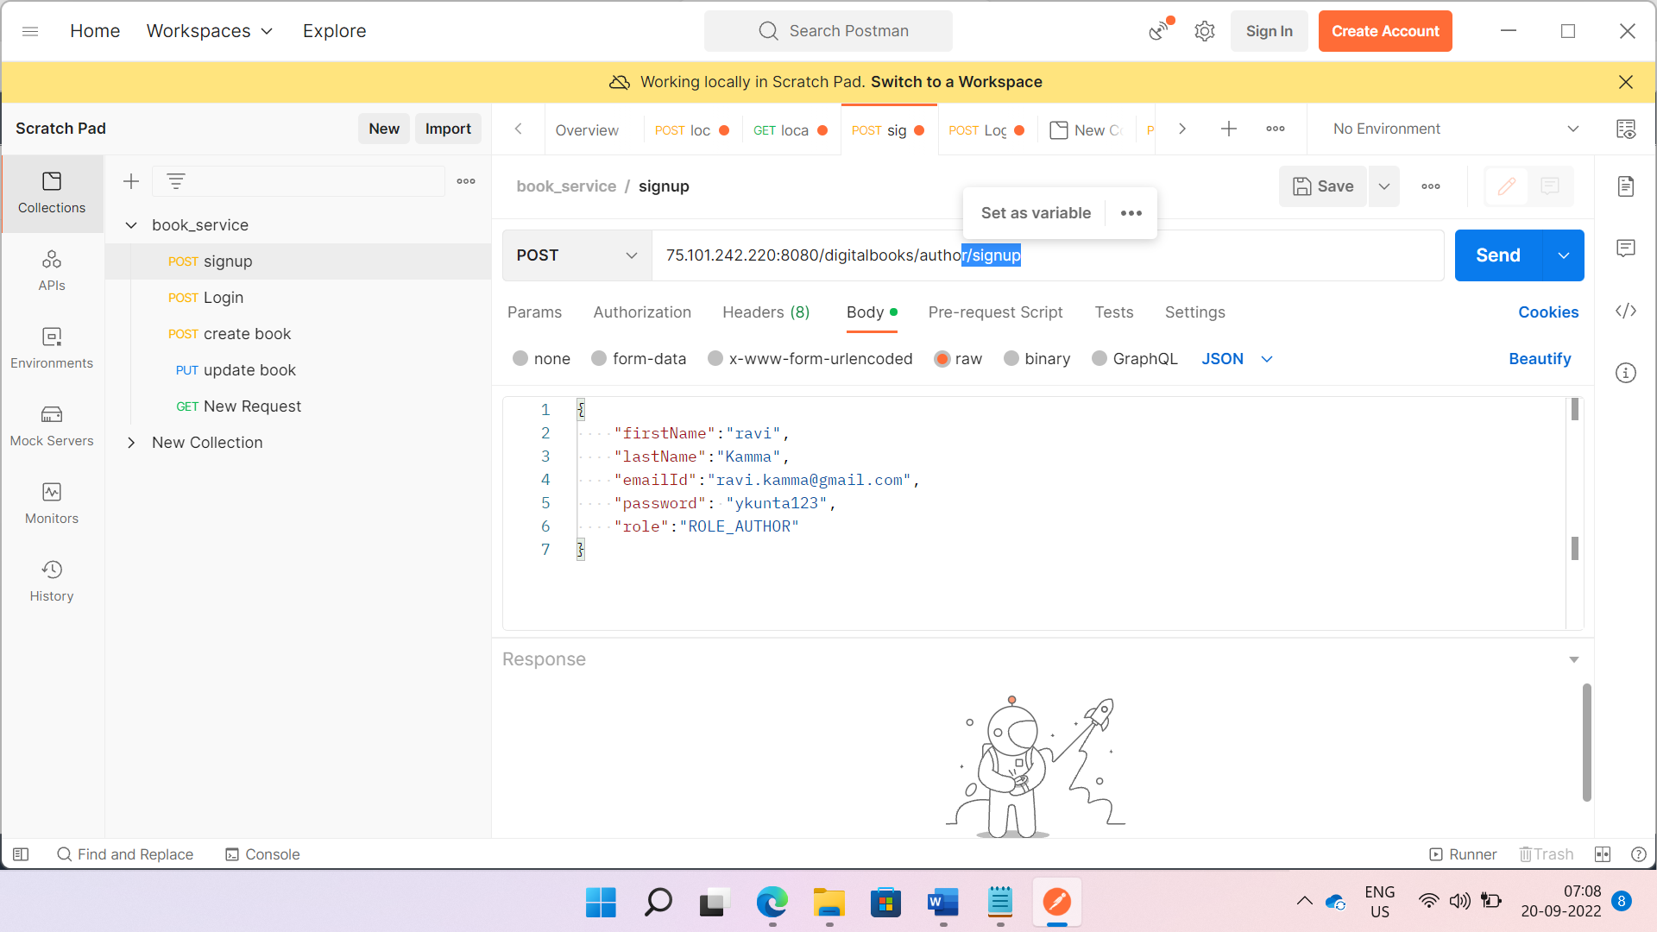

3.Creating API Gateway

Search API Gateway from search box. Create new API

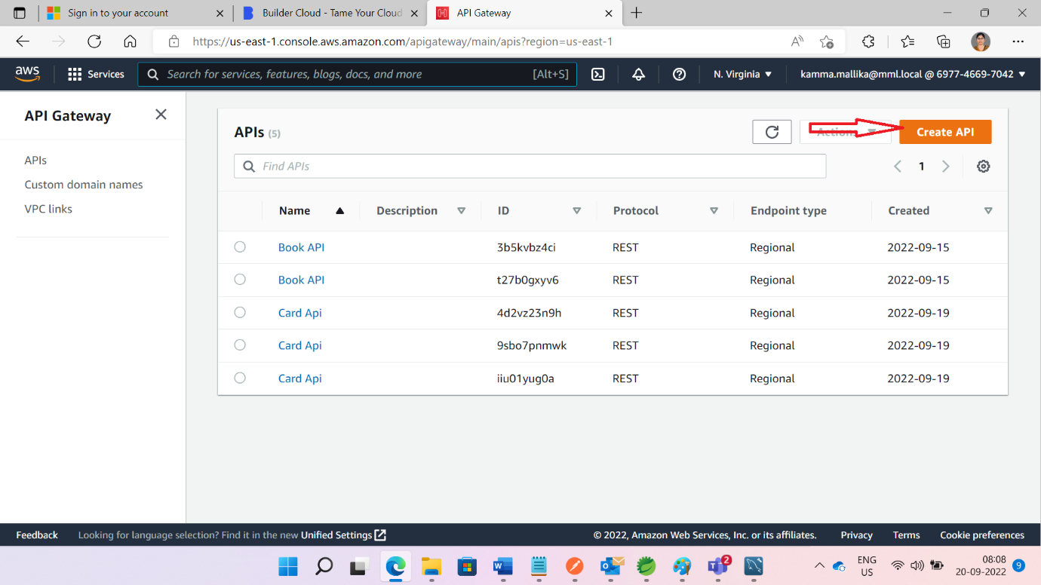

Select the below option

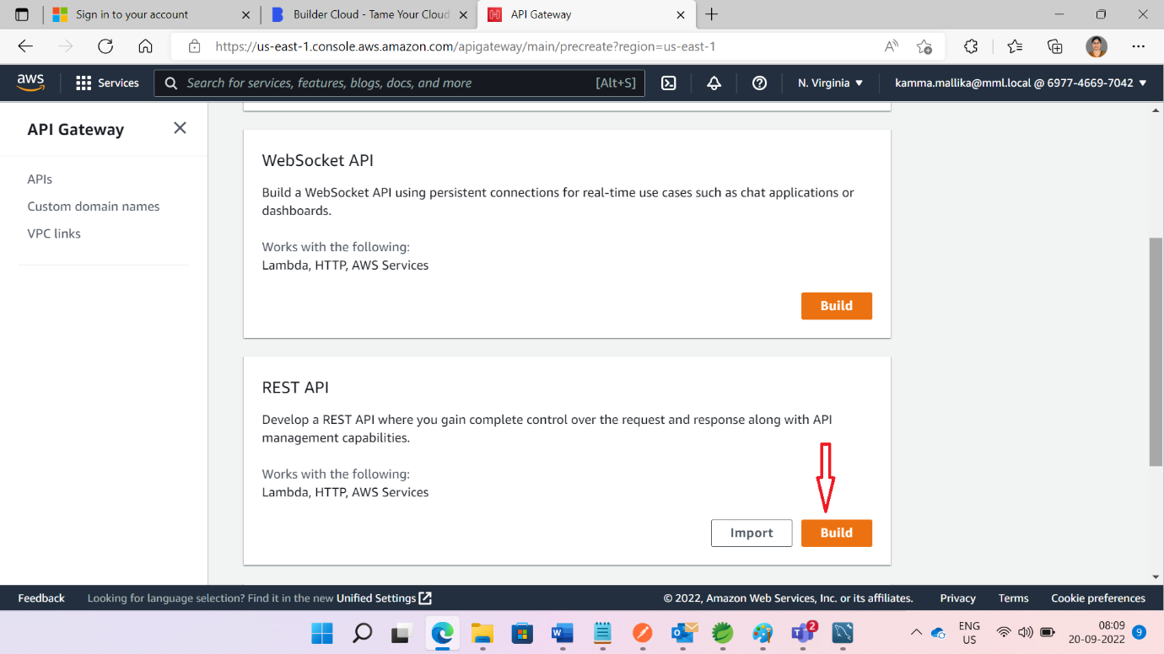

Give the name of the api and click create button.

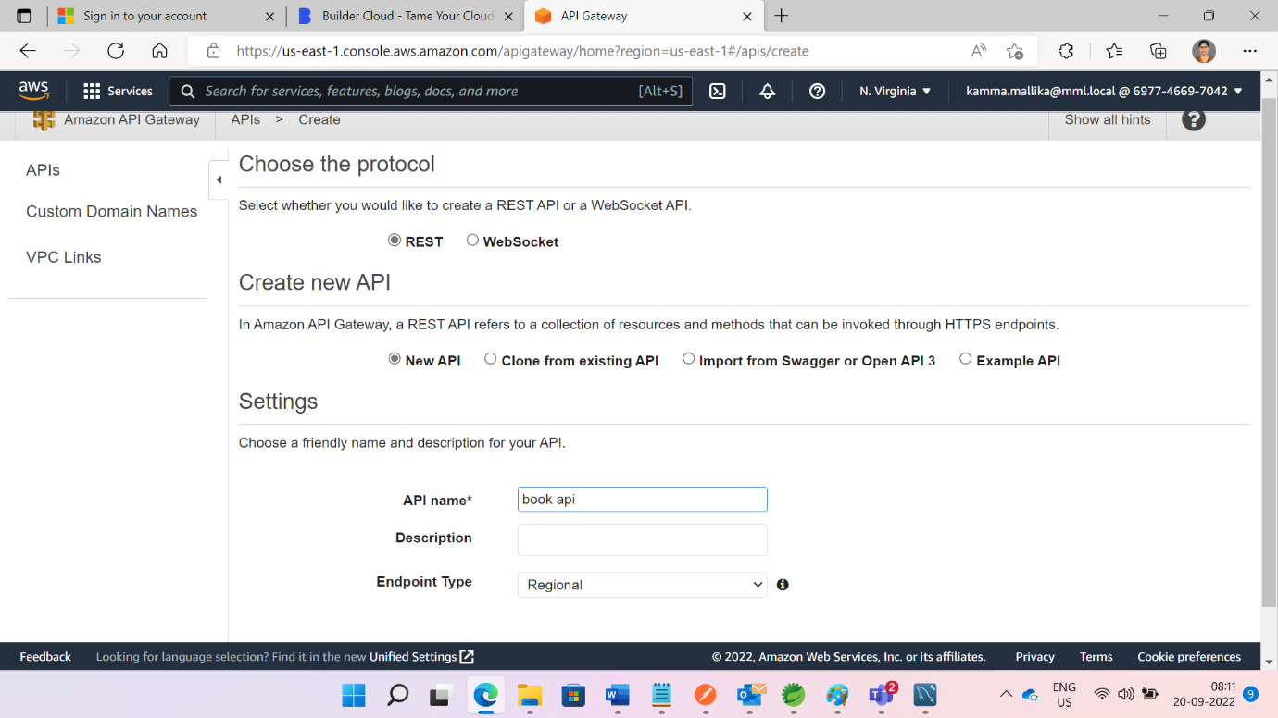

After creating api

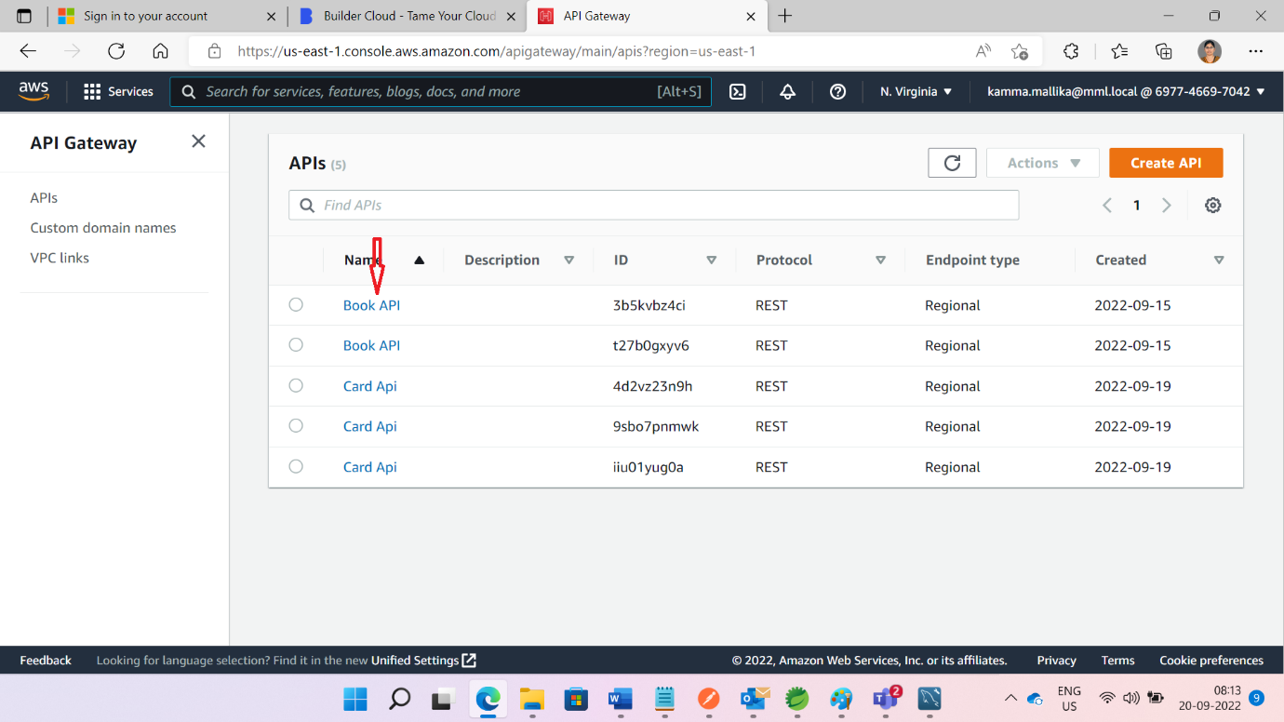

After opening BookAPI and Click on Create Resource

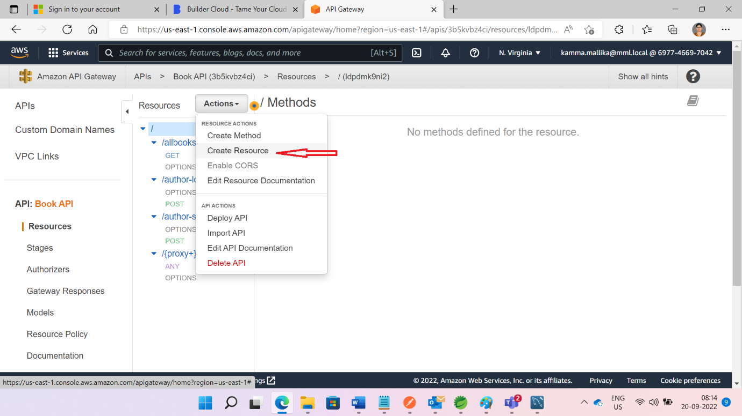

Give proxy resource details like below and click on Create resource.

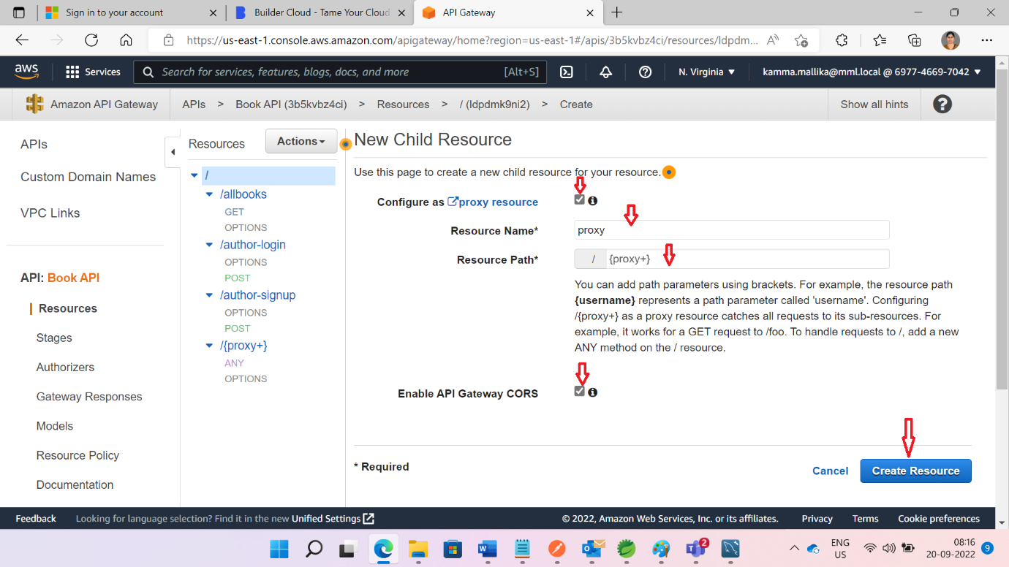

Save theyour base URL details with your Ec2 IPV4 address and port number

Url look like this [http://75.101.242.220:8080/digitalbooks/{proxy}](http://75.101.242.220:8080/digitalbooks/%7bproxy%7d)

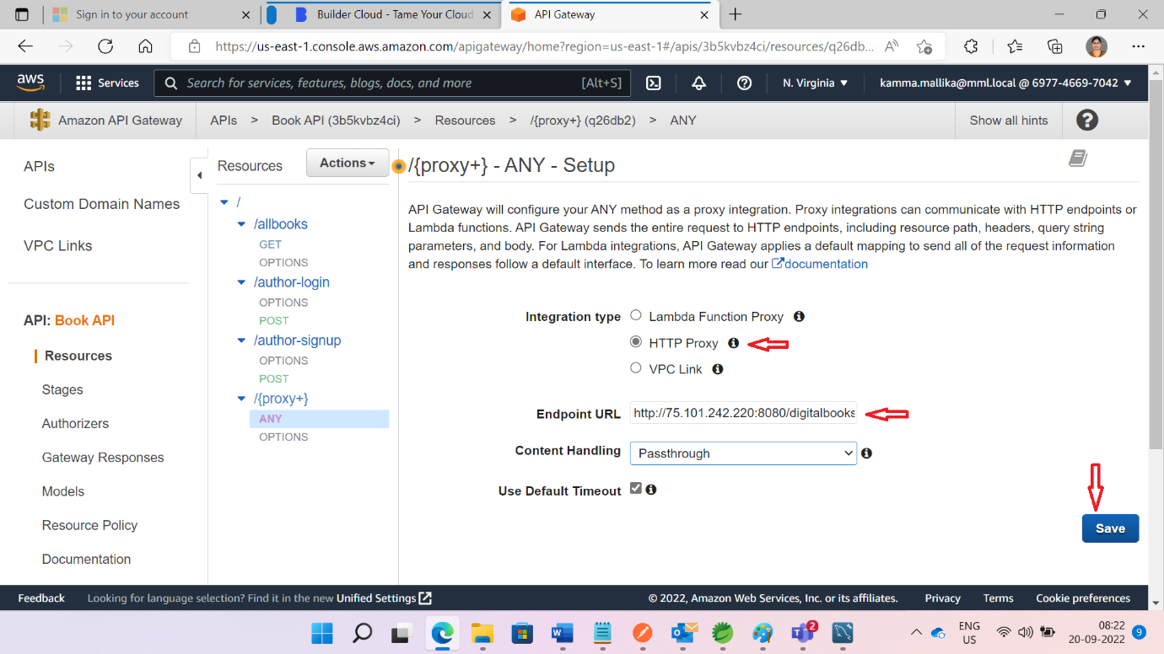

Deploy the API

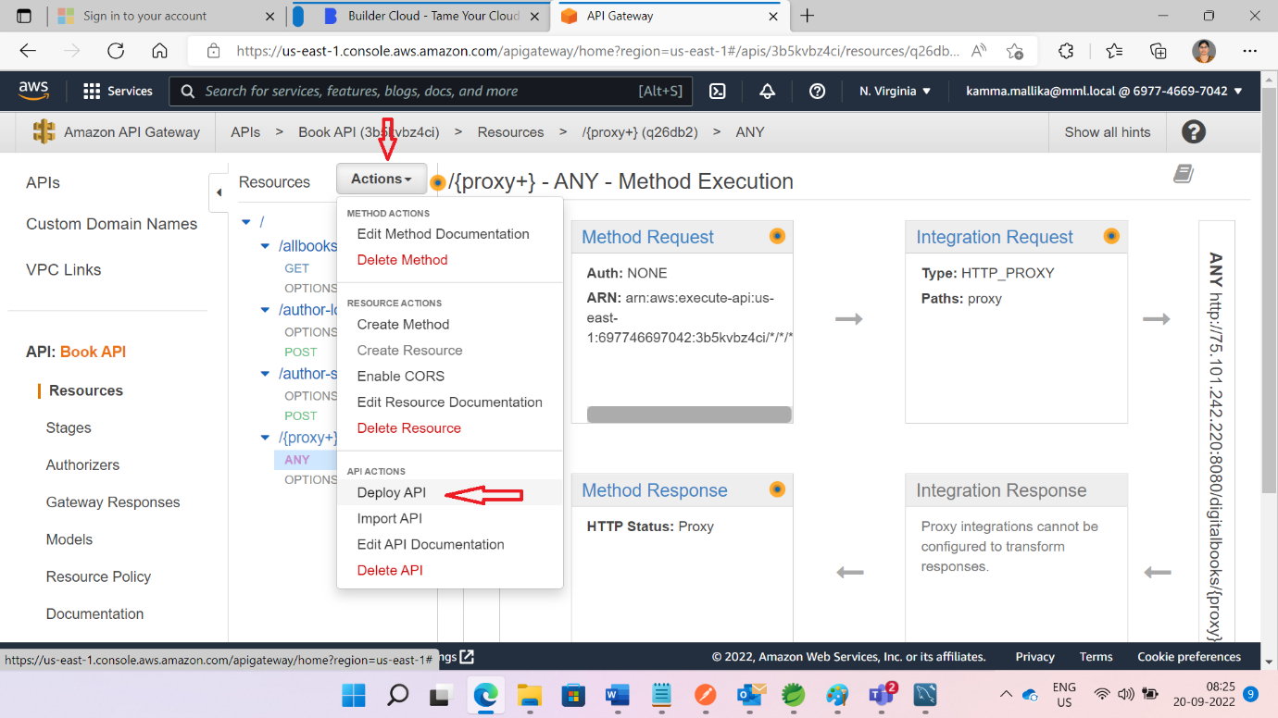

While deploying api if stage is not there create new stage or else use existing stage and deploy button

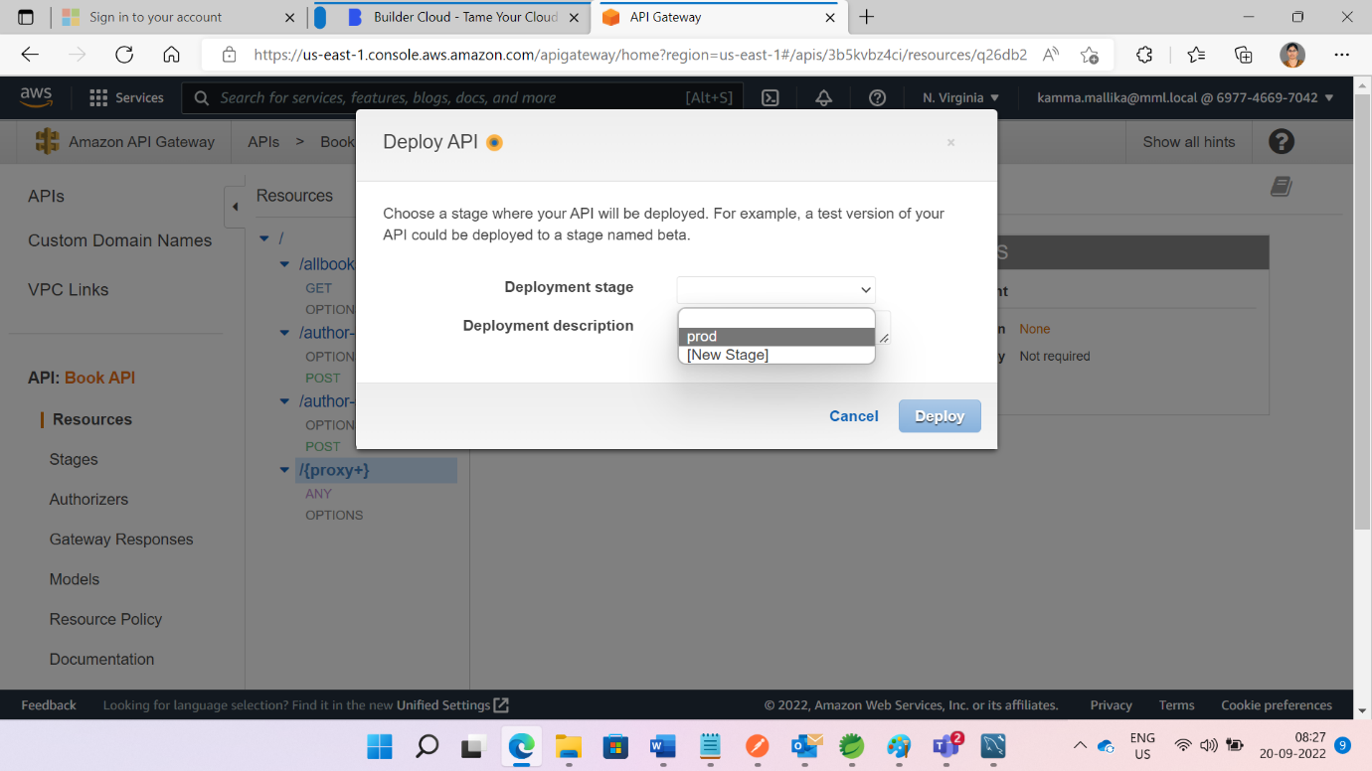

We can usage plan like below

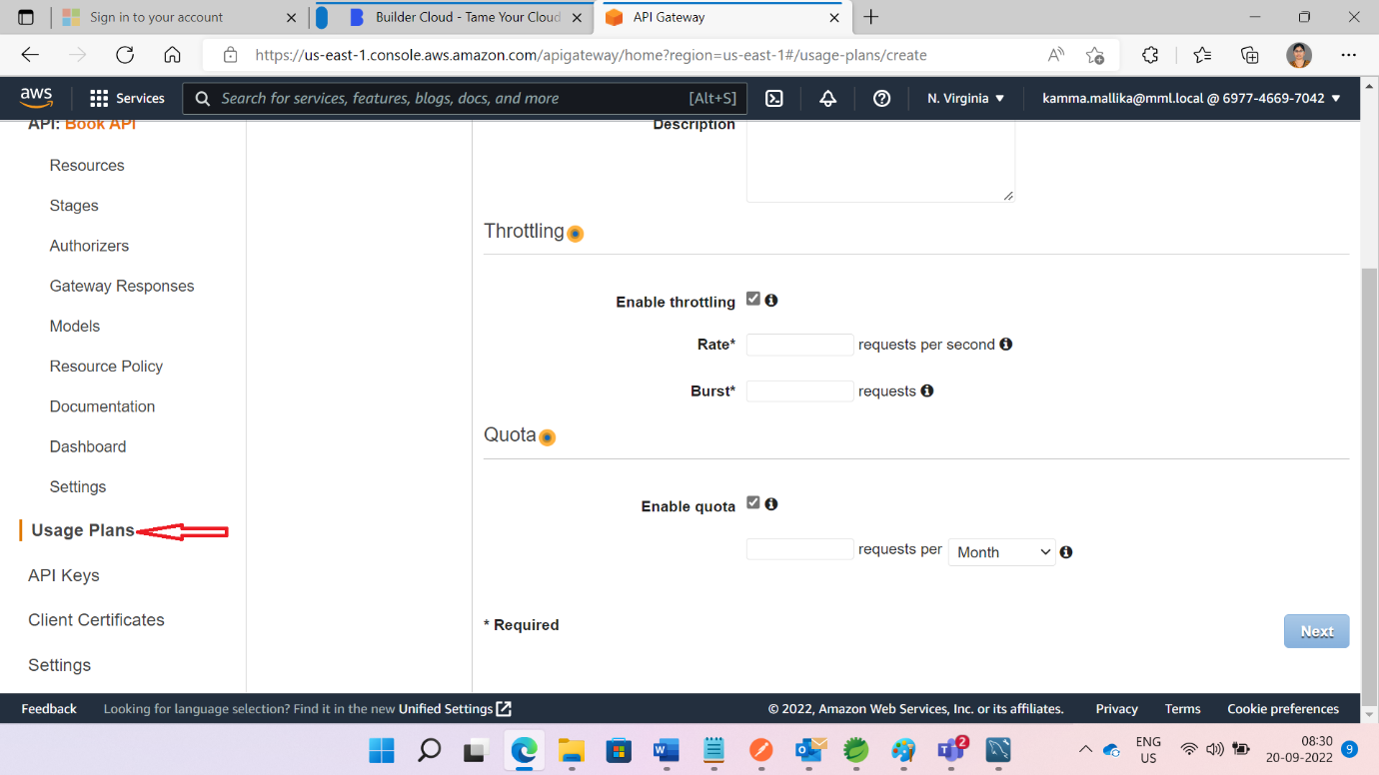

Give nessary information to fileds

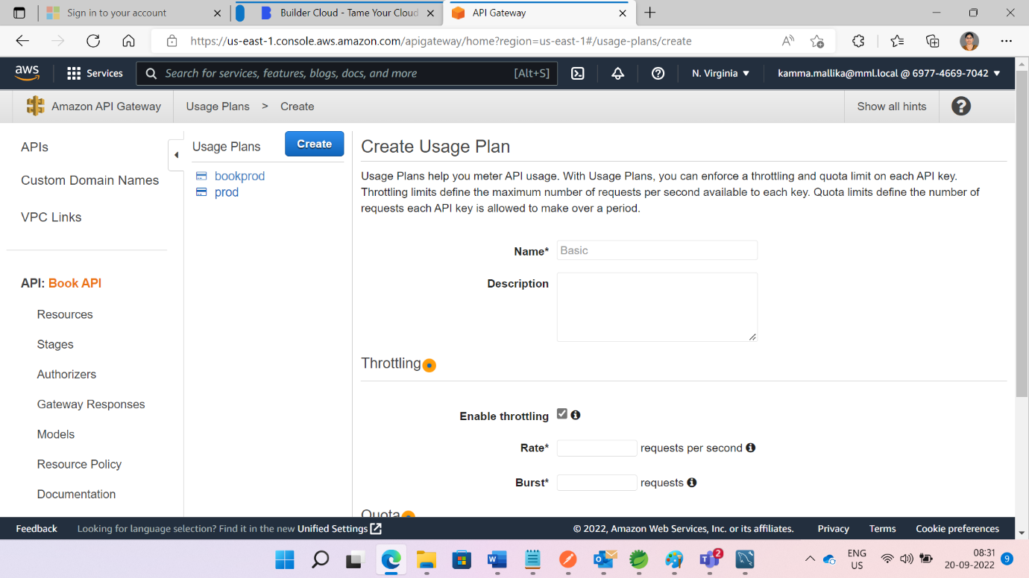

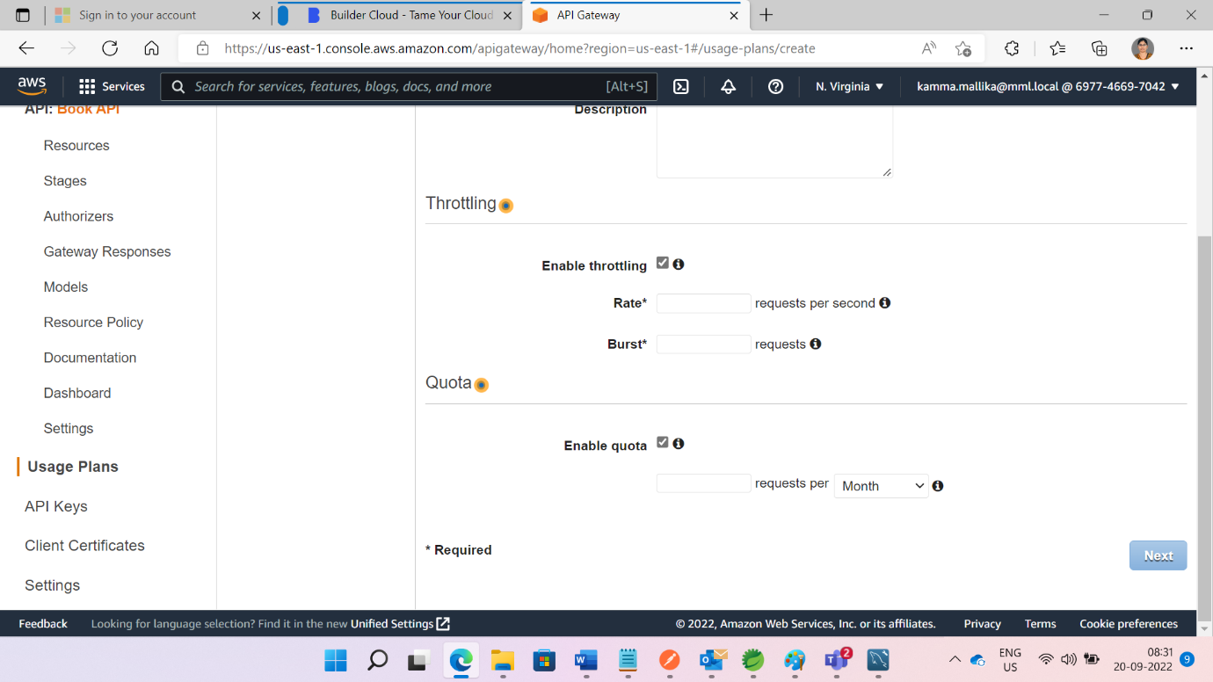

And Click on Next and Choose this usage plan for your API.

Next test the API

Click on Resource and then click on ANY

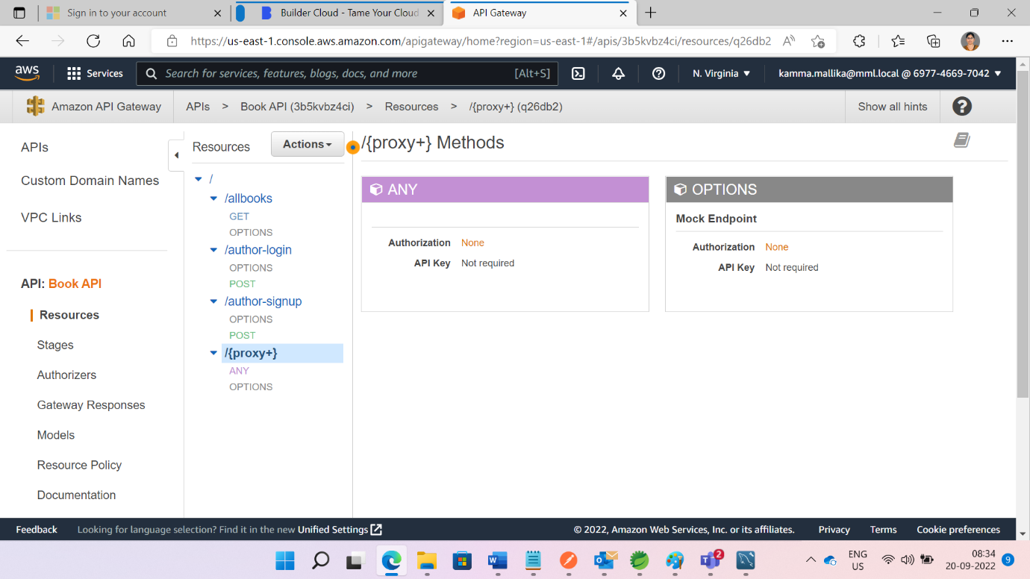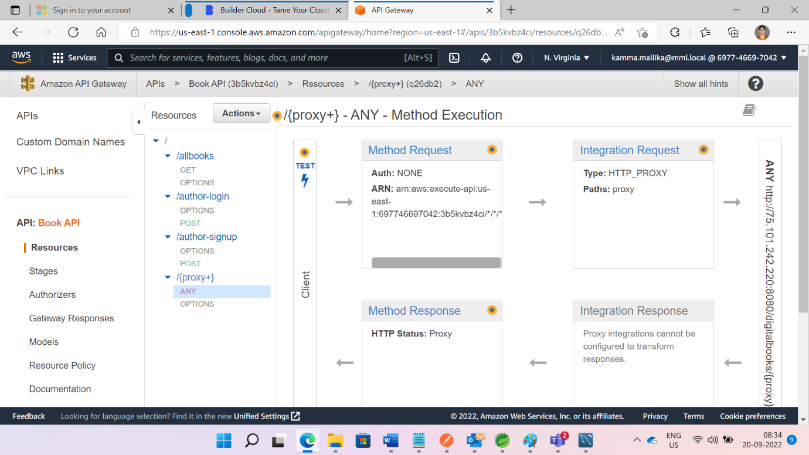

Select POST method from select box and give {proxy} as author/login , give request body for login.

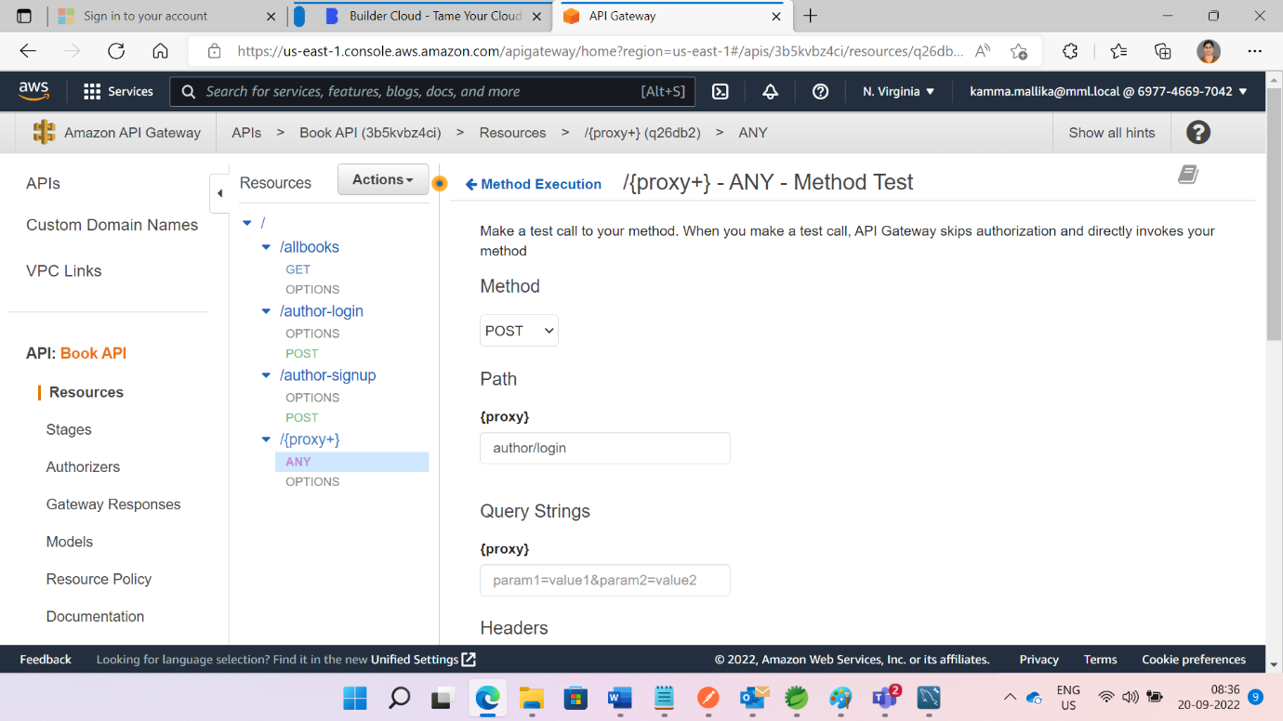

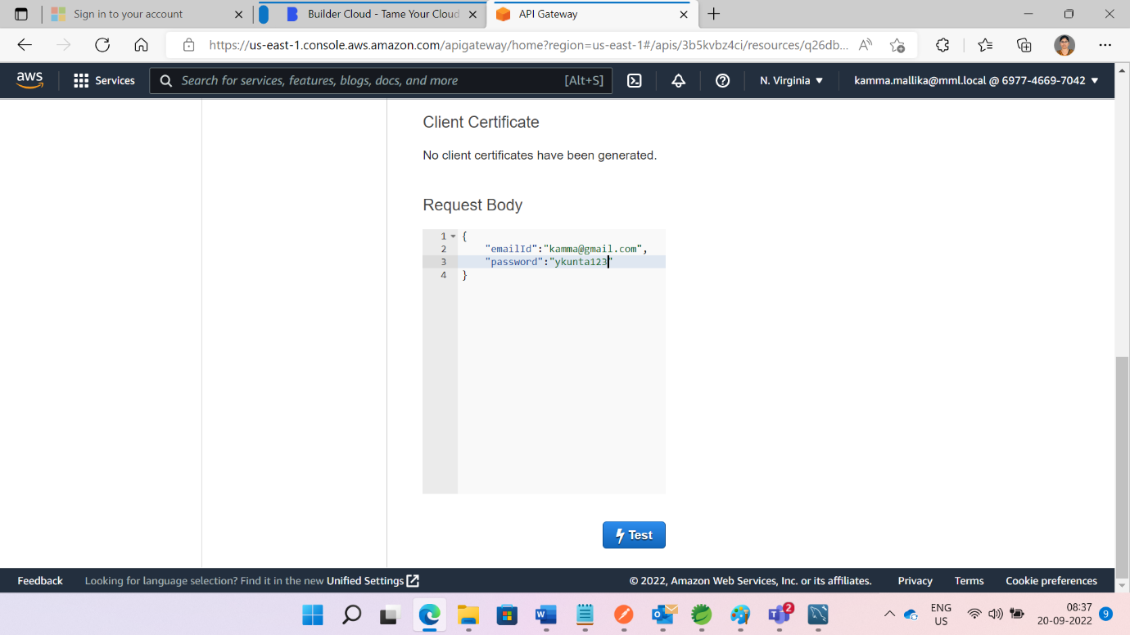

Click on Test button from above pic and see the response like pic

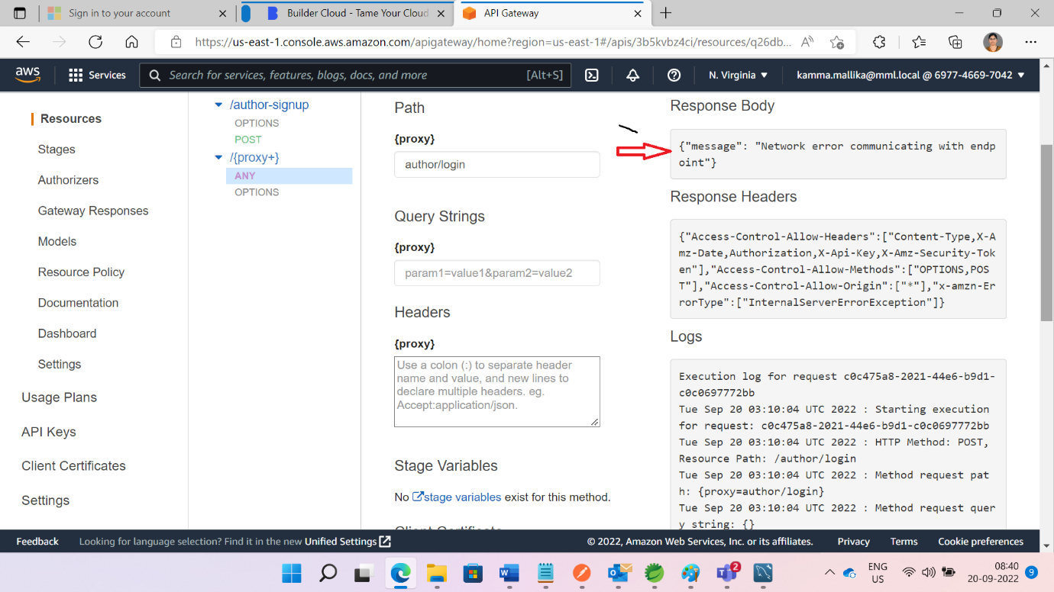

Click on Stage and click on ANY

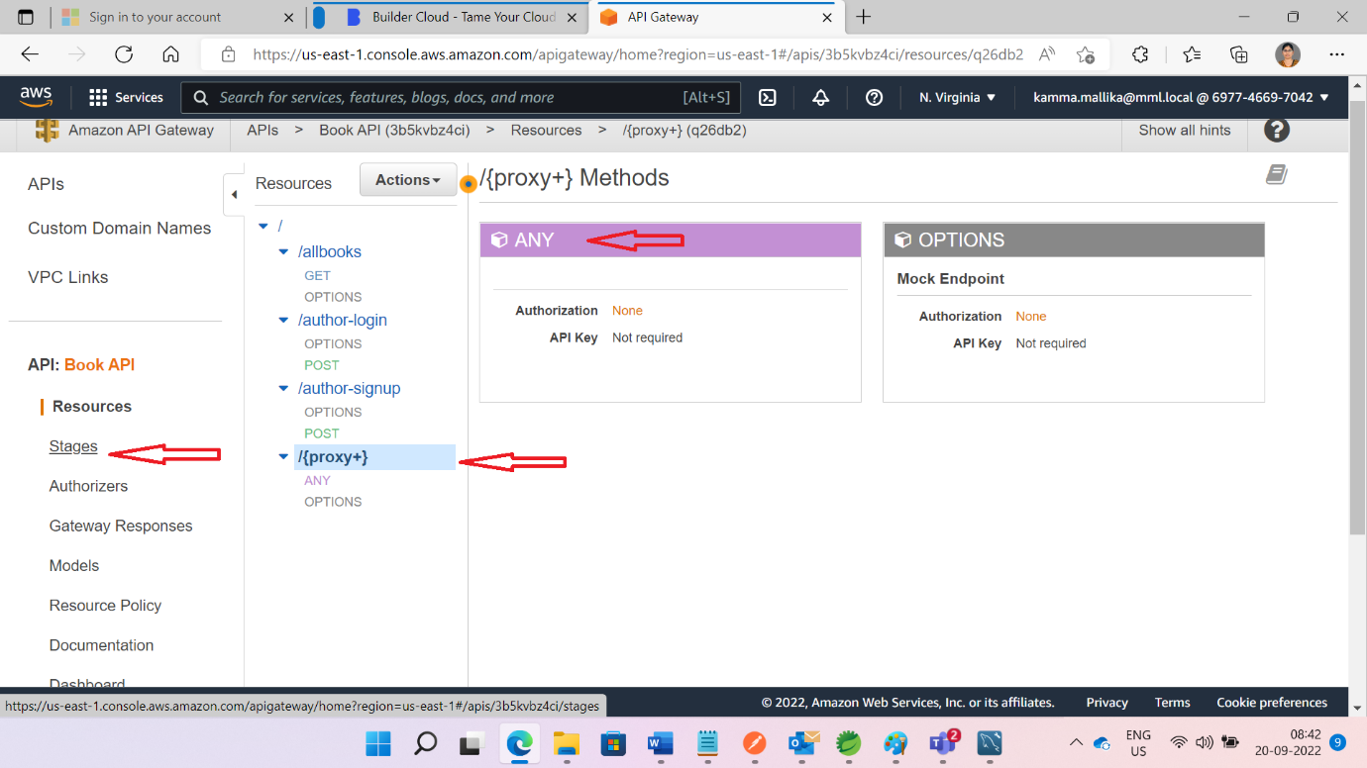

We can proxy all methods we can see from below pic

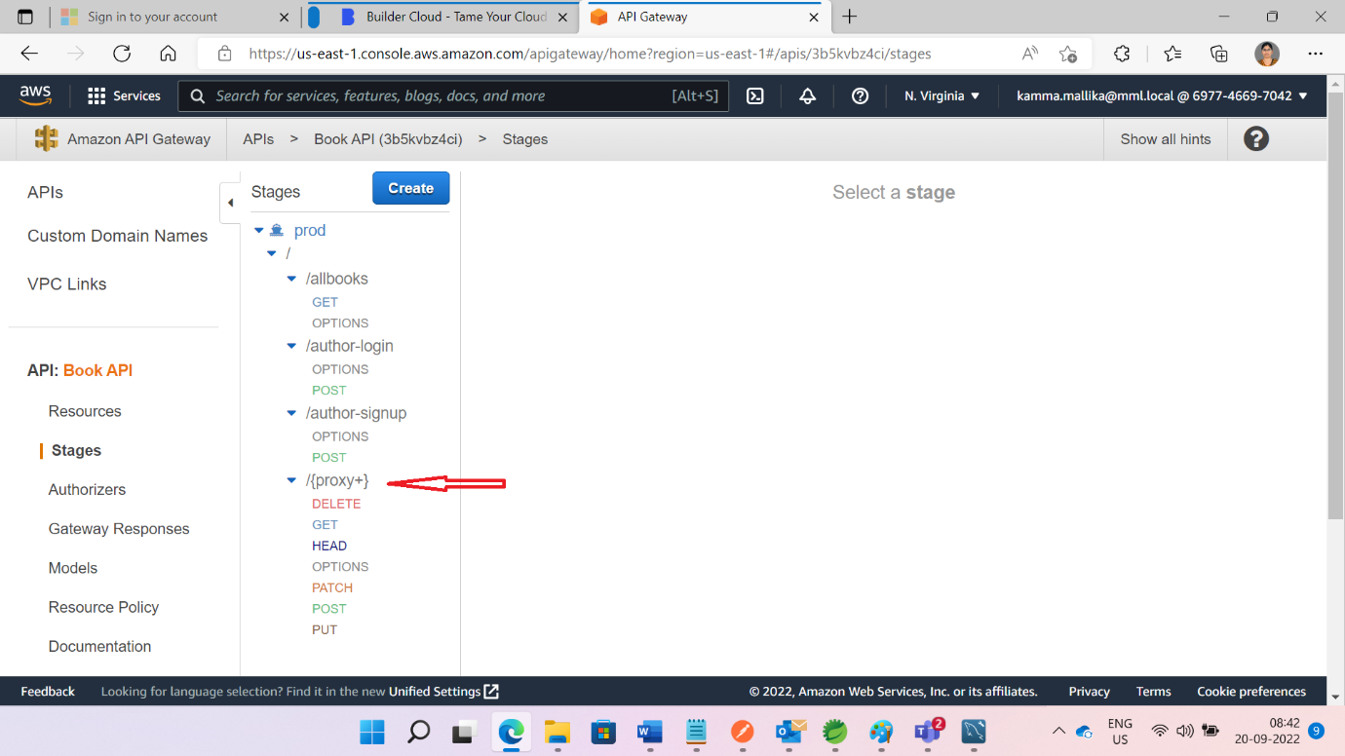

Finally generated URL from below pic. By using these URLS we can access end points

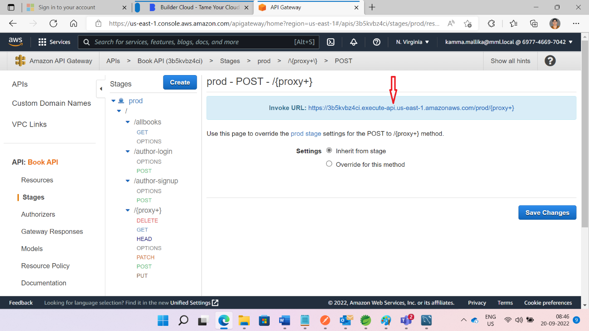

Example :

Base URL:  [https://3b5kvbz4ci.execute-api.us-east-1.amazonaws.com/prod/{proxy+}](https://3b5kvbz4ci.execute-api.us-east-1.amazonaws.com/prod/%7bproxy+%7d)

Test these from post man

Use : https://3b5kvbz4ci.execute-api.us-east-1.amazonaws.com/prod/author/login

4.S3 bucket

Search s3 bucket from search box. Click on Create button.

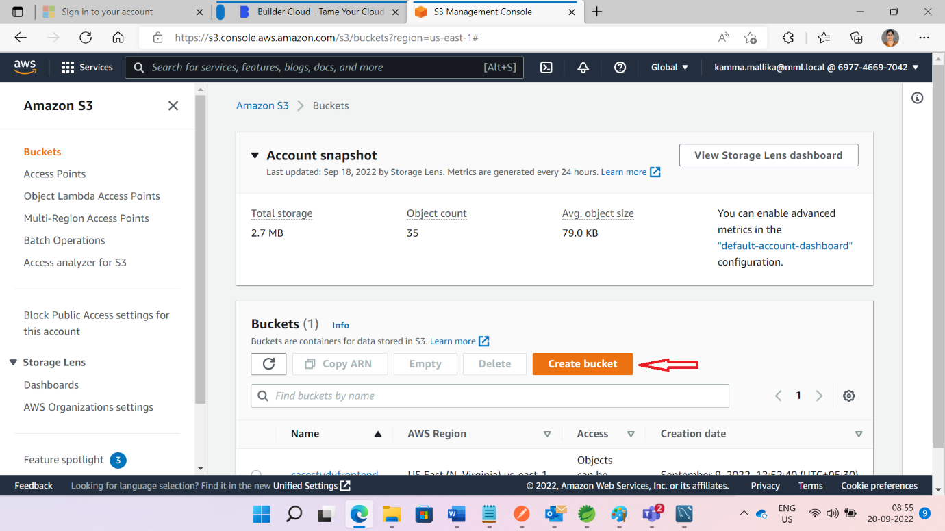

Give name of the bucket name

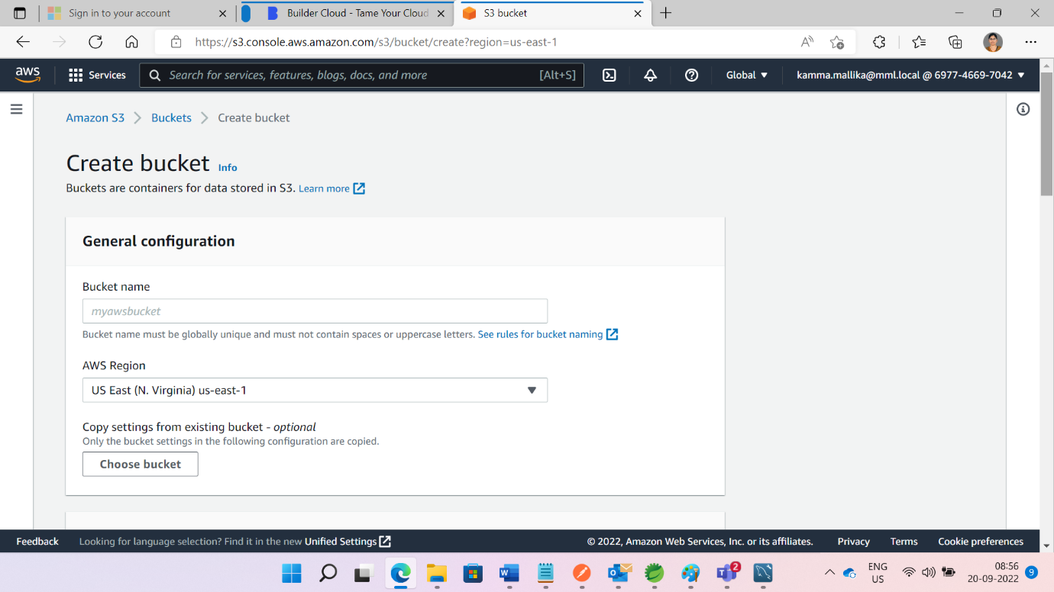

Click on ACLs enabled

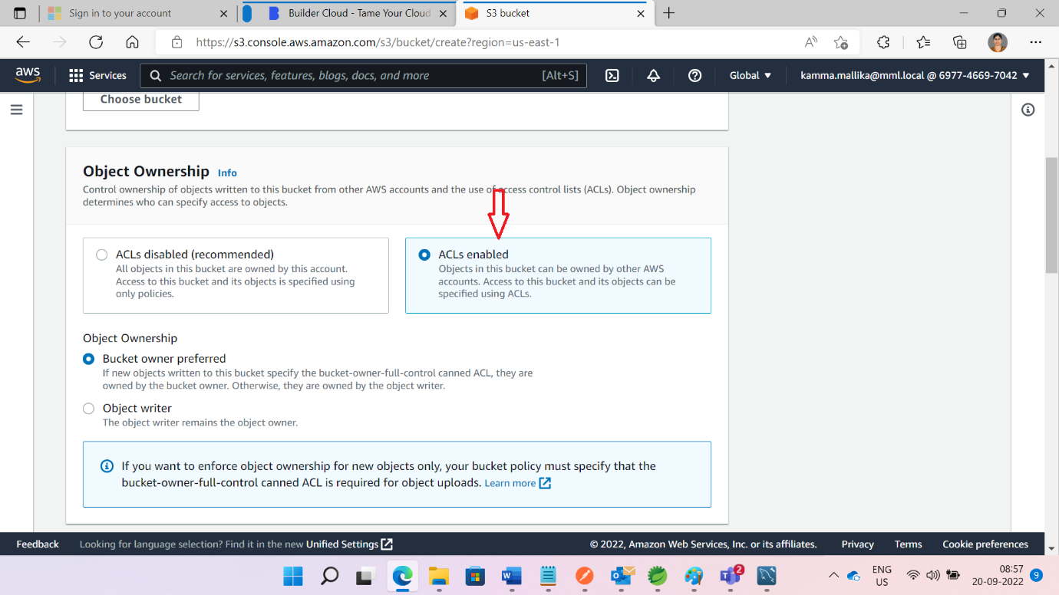

Uncheck the below check box

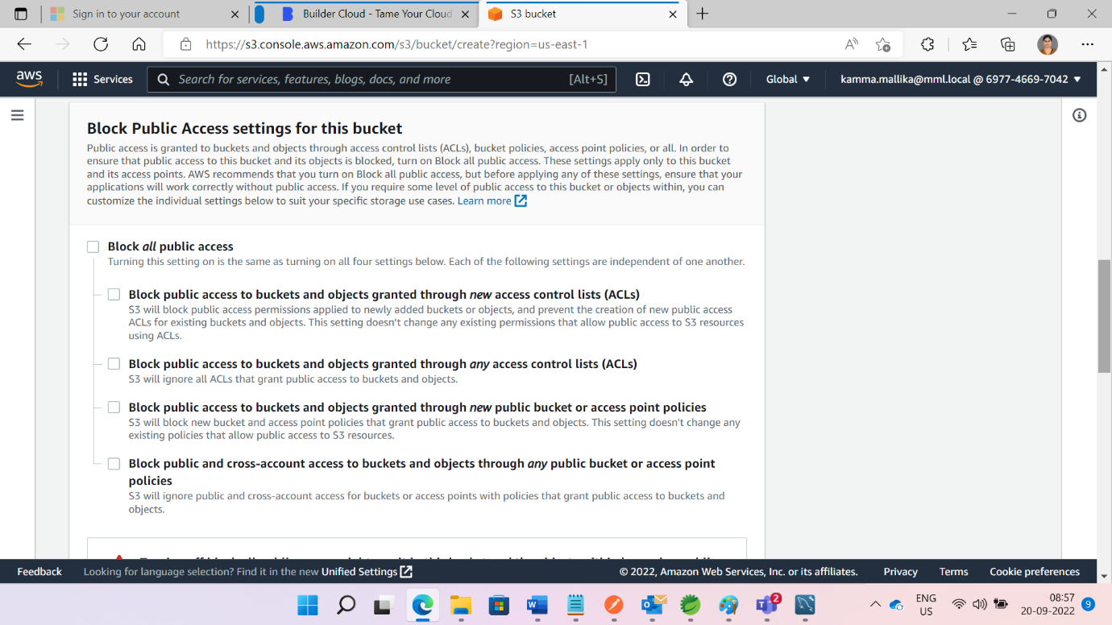

Click on check box

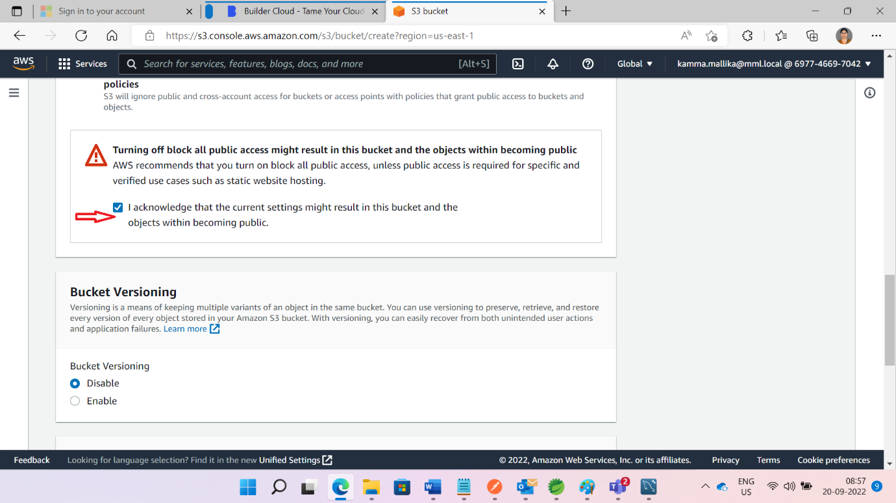

Click on create bucket Button

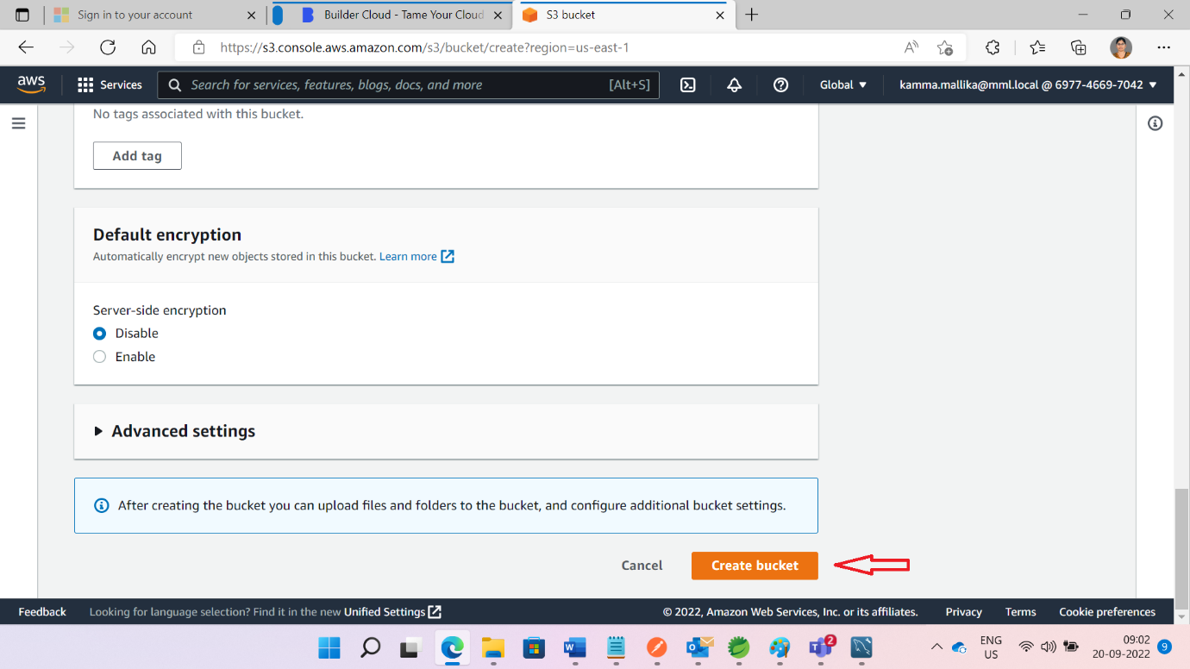

Open the created bucket

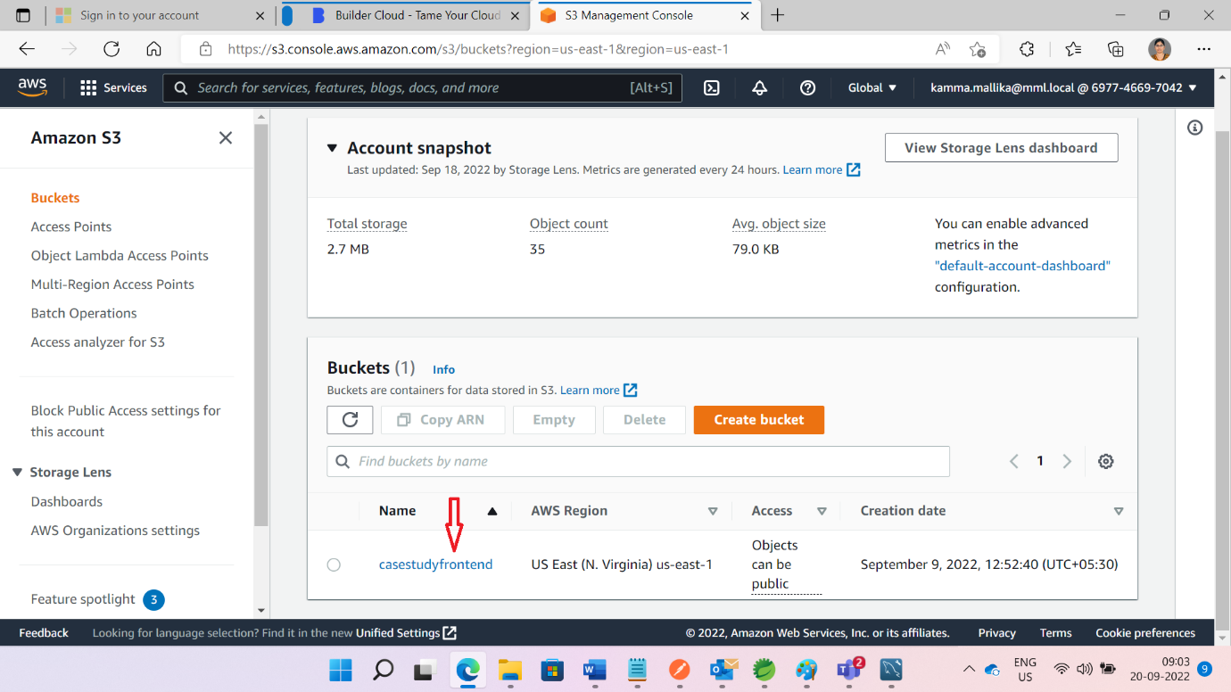

Open angular code from visual studio. Copy API gate way URLS in service file.

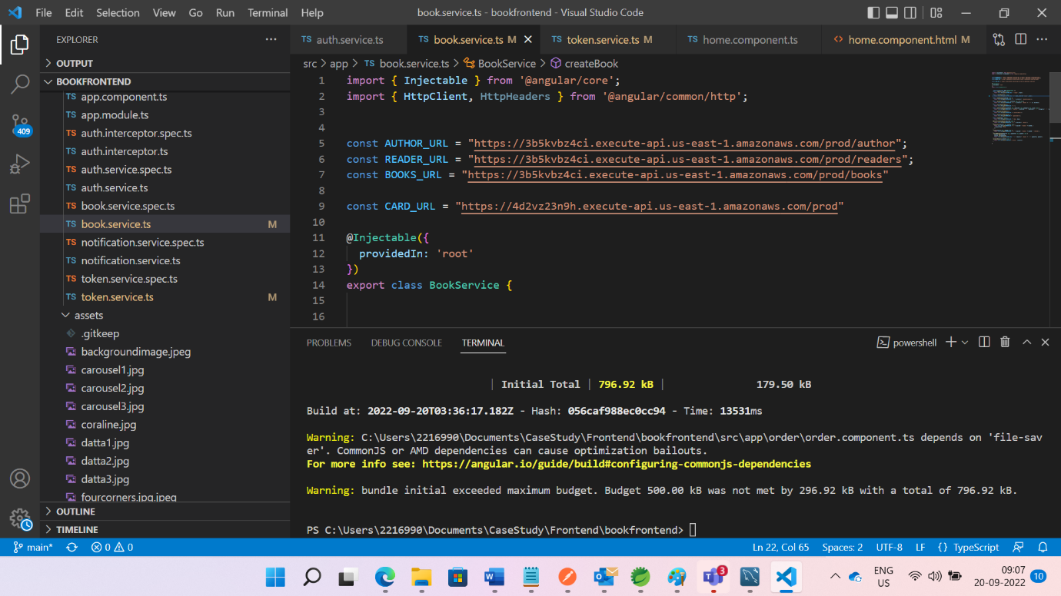

First check application is running or not .If application running successfully .Use ng build command in CMD. Then Dist File will be generated.

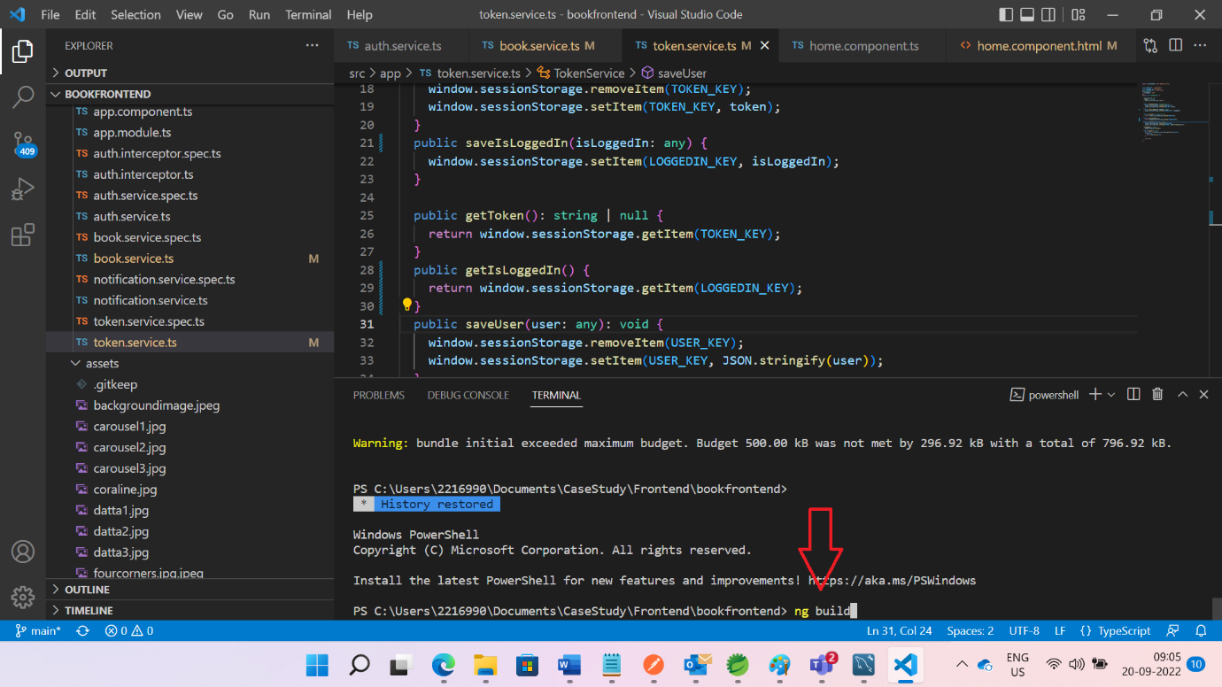

Dist file generated

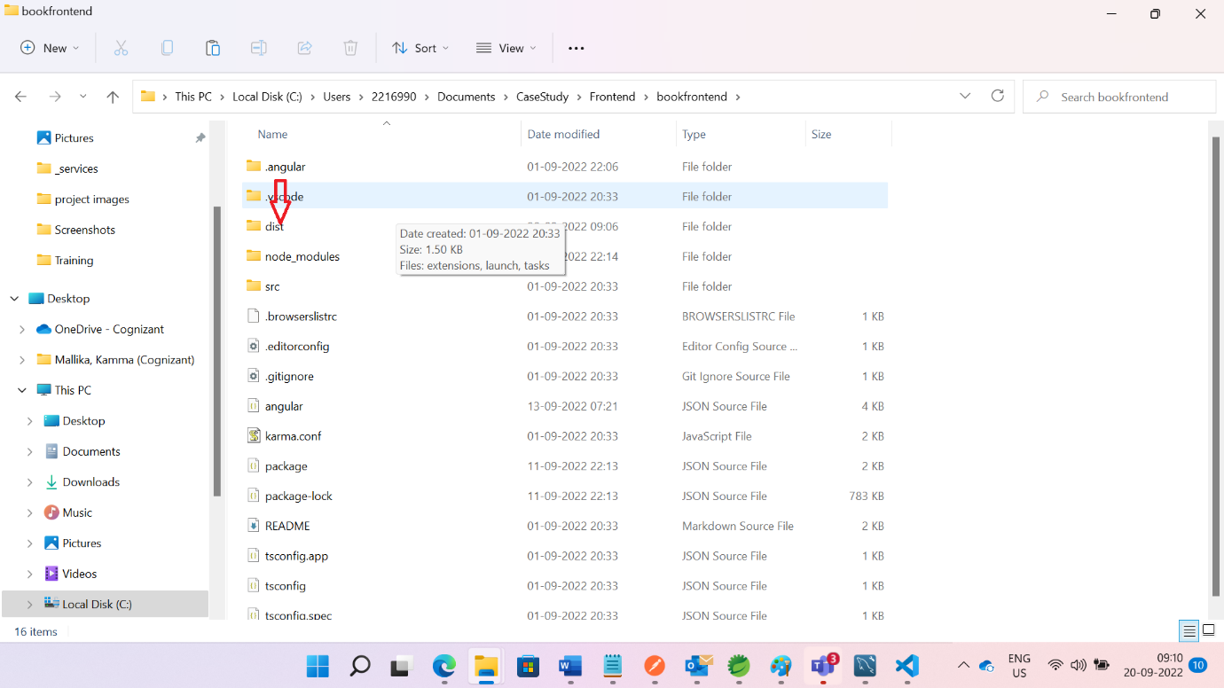

Inside Dist file

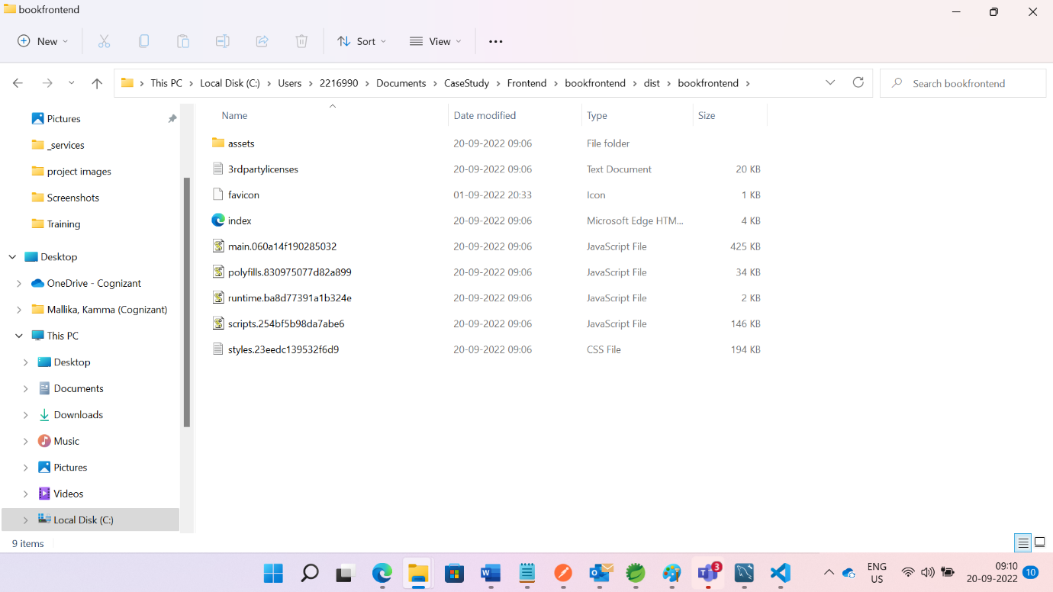

Upload all files from Dist folder to s3 bucket

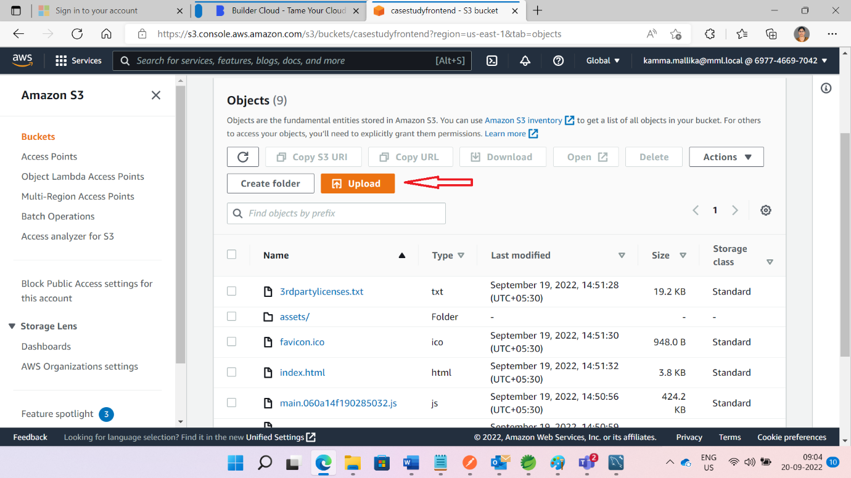

Then make all files as public

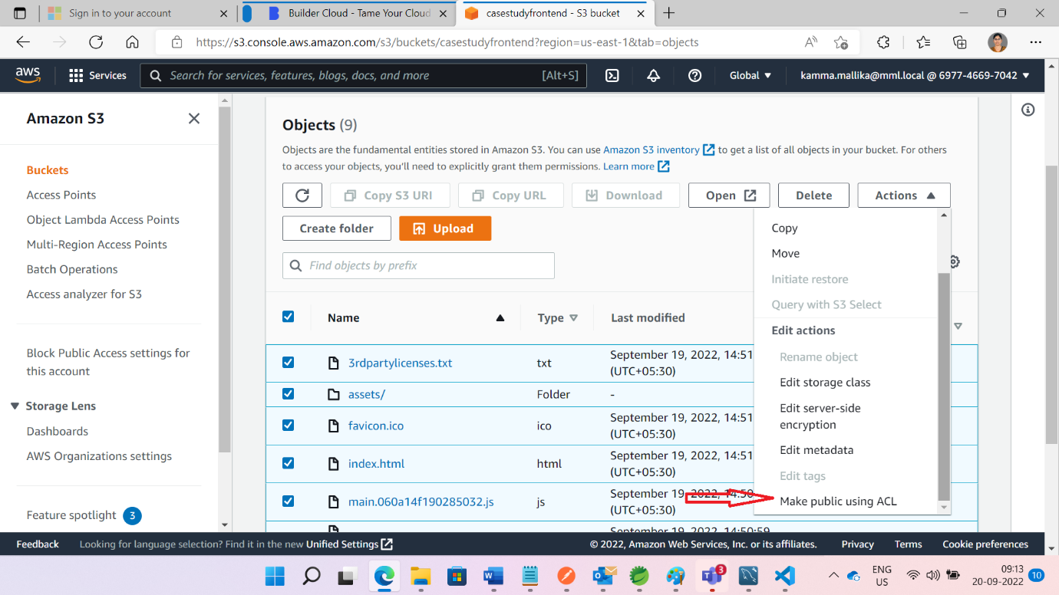

Open index.html and copy url

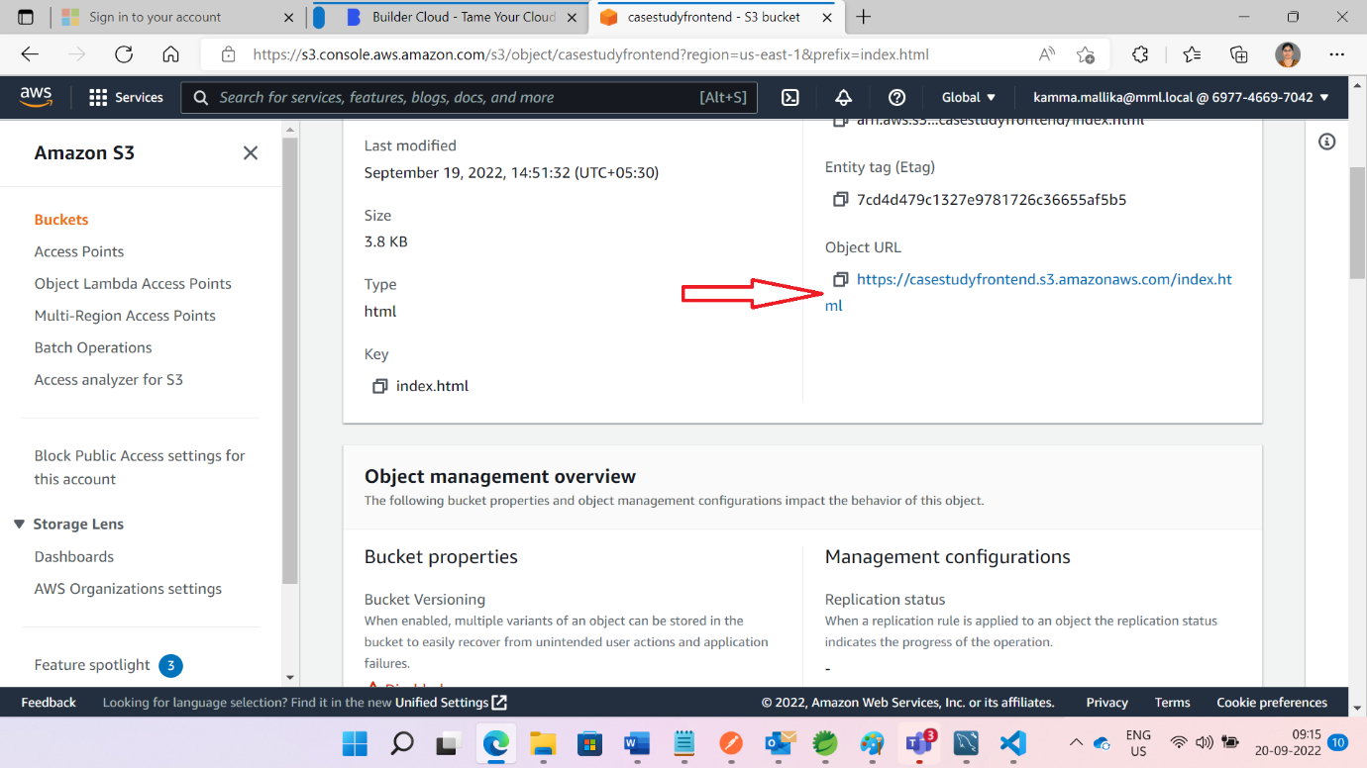

Past that url in browser and page look like this

